**Angular Part - 3**

**Standalone components**An Angular standalone component is a self-contained component that does not need to be declared in an @NgModule. This feature, introduced in Angular 14 and stable in Angular 15+, simplifies the application structure, reduces boilerplate code, and streamlines the development experience. As of Angular 19, standalone is the default for new projects.   
  
Key Concepts

* Self-Contained: A standalone component manages its own dependencies by importing the features it uses (like other components, directives, pipes, or services) directly within its @Component decorator's imports array.
* Module-less: It removes the need for the traditional declarations and imports arrays within a separate @NgModule file, making the component definition clearer and more modular.
* Improved Performance: This architecture enables better "tree-shaking" (removing unused code) during the build process, which can lead to smaller bundle sizes and faster application startup times.
* Easier Lazy Loading: Standalone components simplify lazy loading, as entire modules are no longer required for this purpose. You can simply use the loadComponent function in your routing configuration.

ng generate component my-standalone --standalone  
  
Alternatively, you can manually set the standalone: true property in the component's metadata:

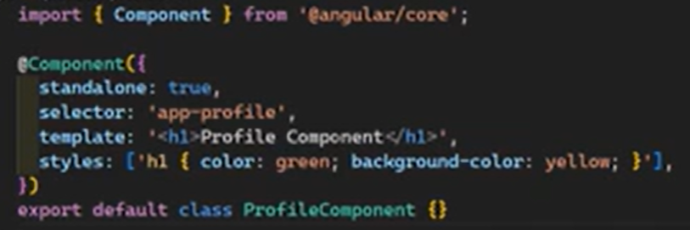

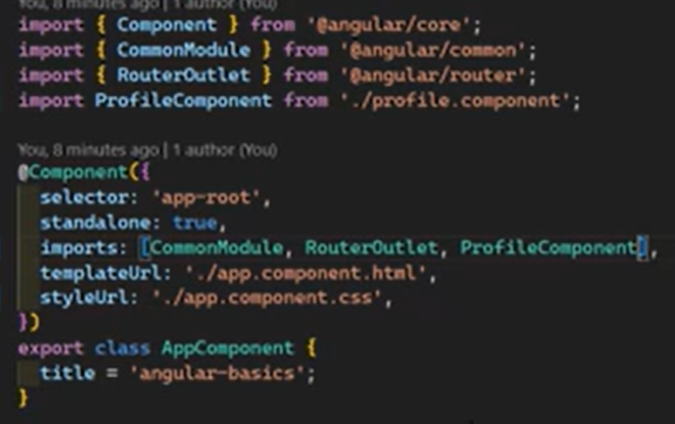

 support of pseudo classes

:host, :host-context, ng-deep pseudo classes for stylings. And also encapsulation levels (none, emulated and shadowDom)

**Leveraging Input Properties for Seamless Component Data Exchange**

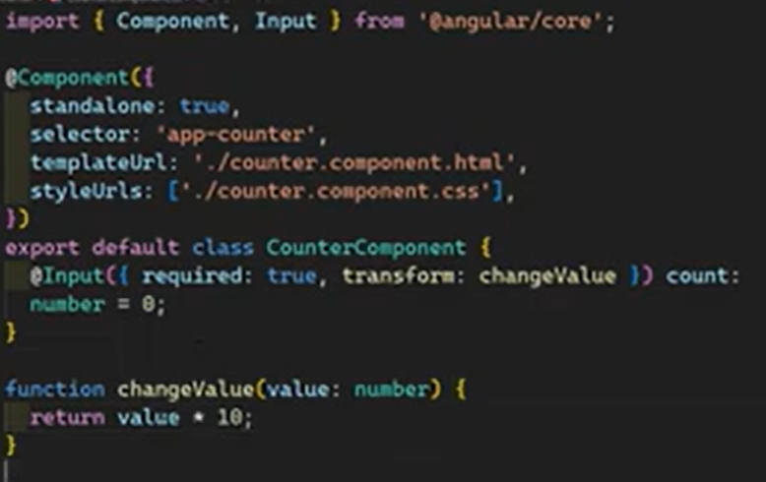

Example:  
  
export class OrderCategoriesPage implements OnInit, OnDestroy{

numval: number = 0;

changeDetectorRef!: ChangeDetectorRef;

constructor(private router: Router, private cdr: ChangeDetectorRef) {

this.changeDetectorRef = cdr

}

ngOnInit(): void {

setInterval(() => {

this.numval = this.numval + 2;

this.changeDetectorRef.markForCheck(); // force re-render

}, 1000)

}

}

<div class="mt-5">

<div>

<app-counter [count]="numval" ></app-counter>

</div>

</div>

import { Component, Input } from '@angular/core';

import { RedTextDirective } from '../../directives/red-text.directive';

@Component({

standalone: true,

selector: 'app-counter',

imports: [RedTextDirective],

templateUrl: './counter.html',

styleUrl: './counter.css',

})

export class Counter {

@Input() count: number = 0;

}

Inbuilt transforms (boolean attribute and numberattribute)

  
  
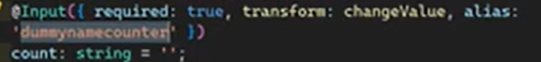  
  
  
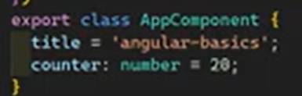

**Getters and setters**  
  
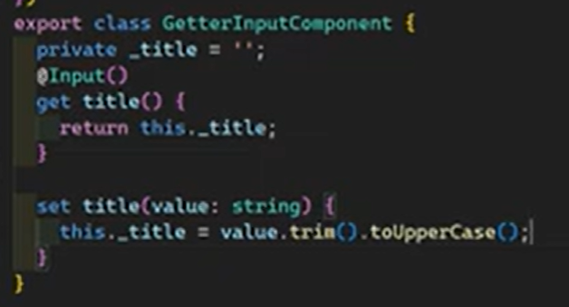  
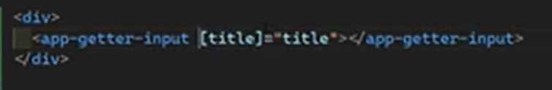  
   
  
Inheritance  
  
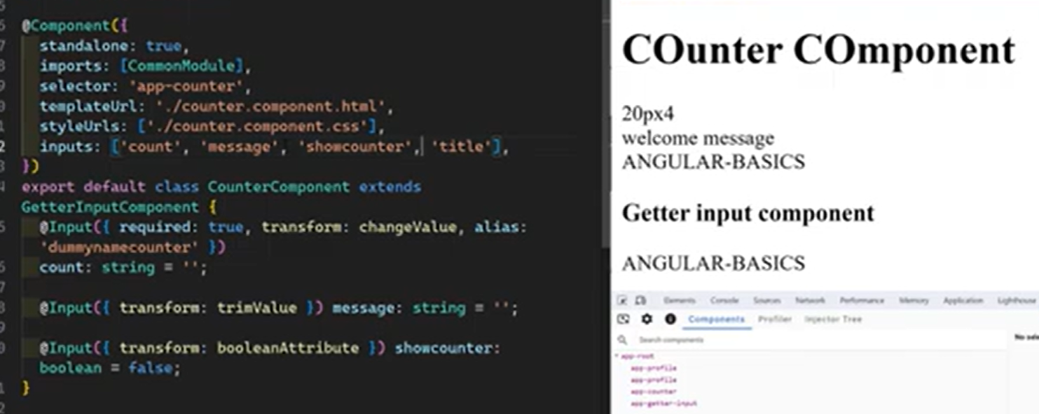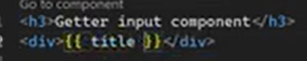

**Send Custom Events Using Output Decorator**There is App component and Panel component, panel component as a child component resides in the app component. We are trying to send data from the child to the parent (panel -> app)  
  
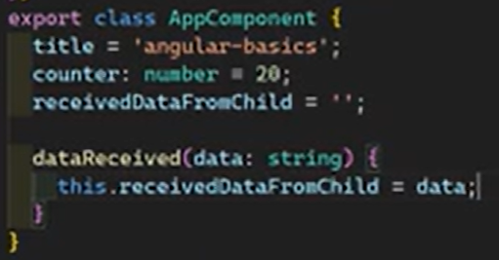  
  
App component   
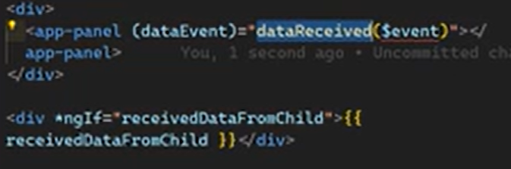  
  
Panel component  
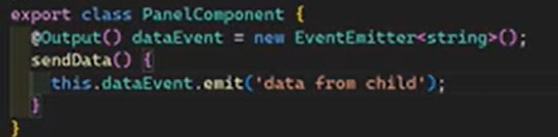  
  
Panel component  
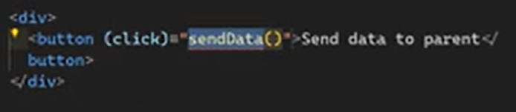  
  
  
**Ng-content - rendering child content  
  
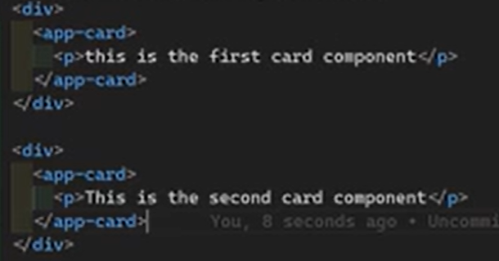**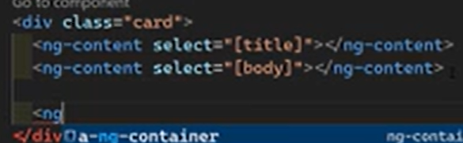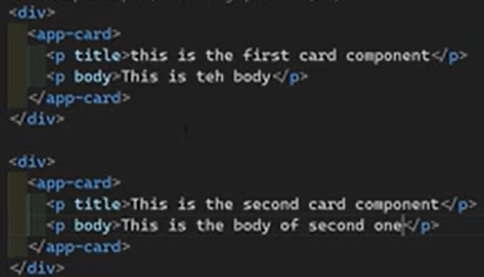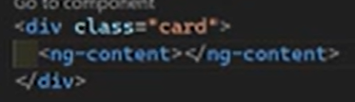

In Angular, the host element is the DOM element that matches a component's or directive's selector. It acts as the container for the component's rendered template and view.

For example, if you define a component with the selector app-user-profile, the corresponding HTML element <app-user-profile> in your application's main HTML file (or another component's template) is its host element.

Interacting with the Host Element

Angular provides several ways to interact with the host element from within the component or directive's class:

* Styling: You can target and style the host element using the special :host CSS pseudo-class selector within the component's stylesheet. This allows you to apply styles to the container itself, while maintaining view encapsulation.
* Binding: You can bind properties, attributes, and events to the host element. The modern approach is to use the host property within the @Component or @Directive decorator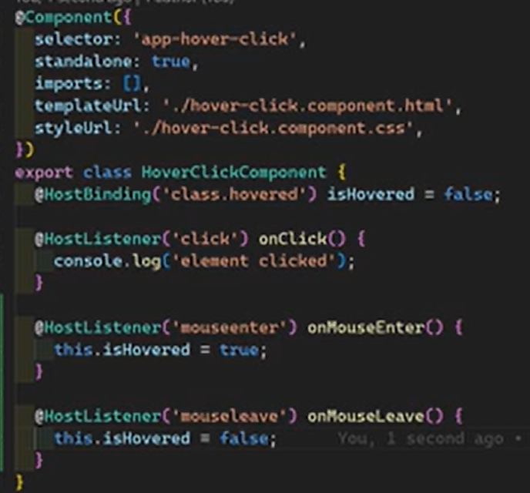

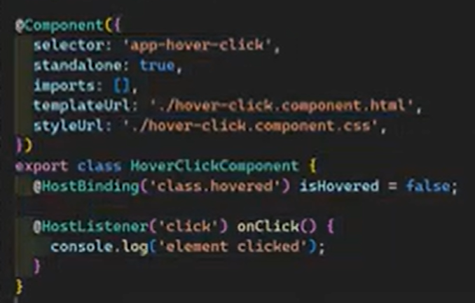

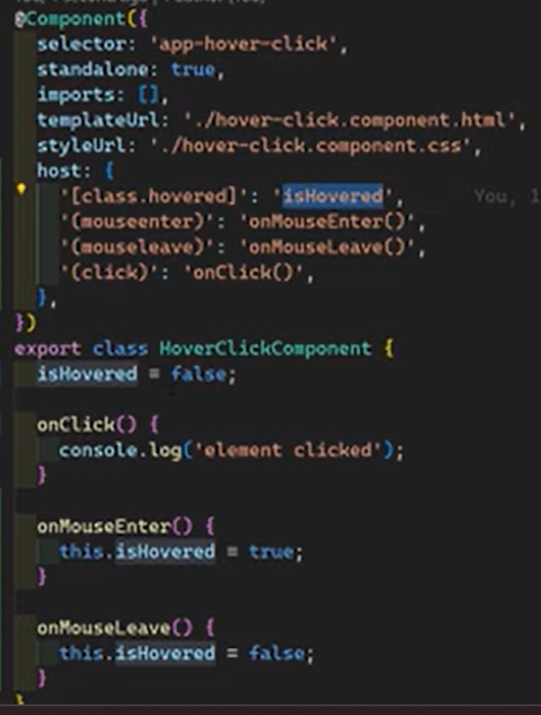

**Alternate to ngOnDestroy lifecycle method**  
  
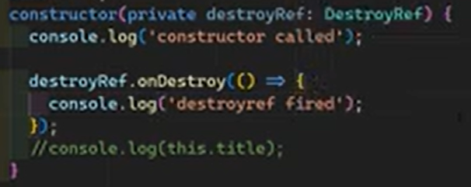

**ngAfterViewInit**

  
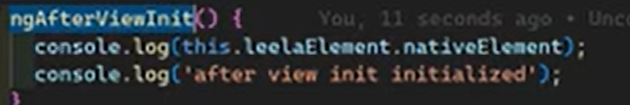

**Access child content components**

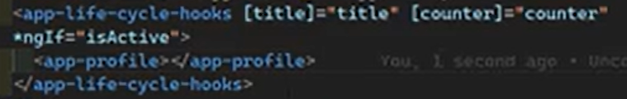

Instead of @ViewChild

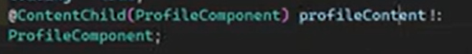

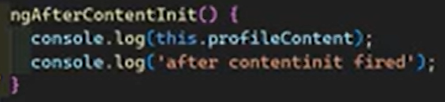

**ngAfterViewChecked**

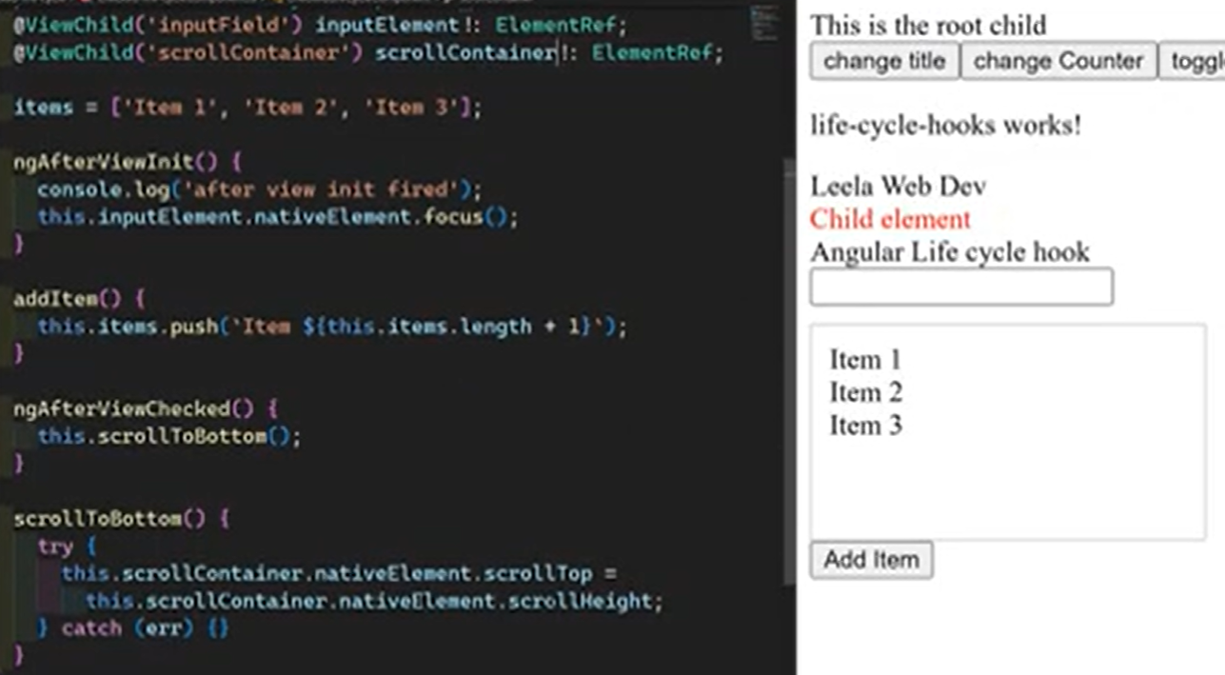

**afterRender & afterNextRender Lifecycle Hooks**

In Angular, afterRender() is a function that registers a callback to run after every change detection cycle completes and the DOM has been updated in the browser. It is primarily used for manual DOM manipulation and synchronizing with third-party libraries when the standard data binding isn't sufficient.

**Key Features**

* Execution Timing: The callback runs after the browser has finished painting the UI, ensuring the DOM is stable and ready for interaction.
* Browser-Only: These functions only run in the browser (client-side) and are ignored during server-side rendering (SSR) or pre-rendering, preventing errors when using browser-specific APIs.
* Application-wide Hook: Unlike traditional component lifecycle hooks (like ngAfterViewInit), afterRender() is an application-wide function that can be called from anywhere in your application (components, services, etc.), provided an injection context is available (e.g., in a constructor).
* Performance Optimization (Phases): You can specify an optional phase (e.g., EarlyRead, Write, Read) to control the order of DOM operations, which helps minimize performance issues like layout thrashing.

**When to Use afterRender()**

* Measuring DOM Elements: Getting the size or location of an element after an update.
* Syncing with Third-Party Libraries: Initializing or updating a library (e.g., a charting library) that requires direct DOM access.
* Manual DOM Updates: Performing complex animations or scrolling to specific elements that need an up-to-date DOM state.

**Related Hooks**

* afterNextRender(): Similar to afterRender(), but the callback runs only once after the next rendering cycle. This is ideal for one-time initialization tasks.
* afterRenderEffect(): Introduced in [Angular 19](https://v17.angular.io/guide/lifecycle-hooks), this combines the timing of afterRender() with the reactivity of signals. The callback executes after rendering, but also reacts to changes in its signal dependencies. This is more specialized and often used for advanced cases involving signal-based state and DOM updates

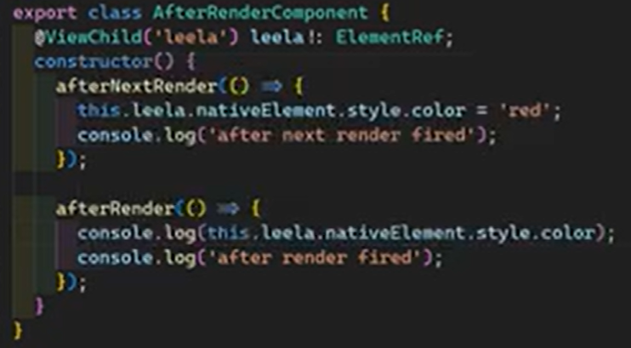

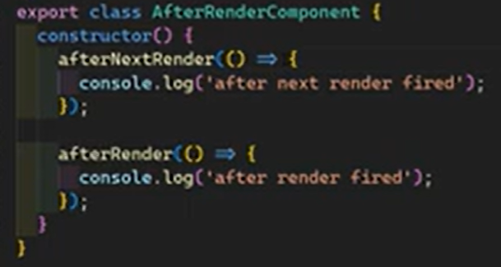

Specifying phases  
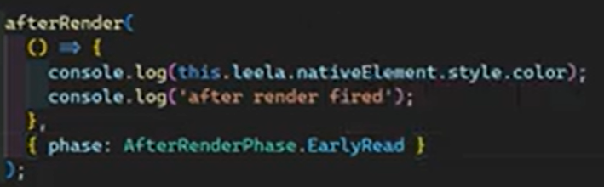 afterrenderphase.read // write  
  
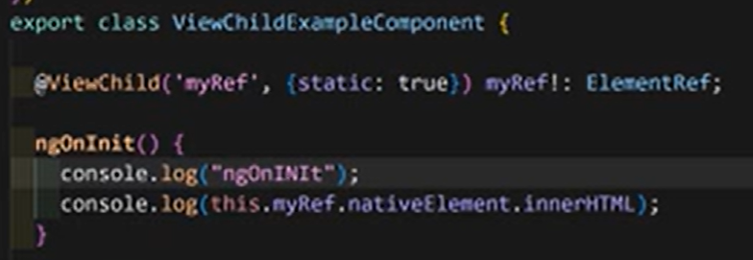  
Static : true allows access before initializing

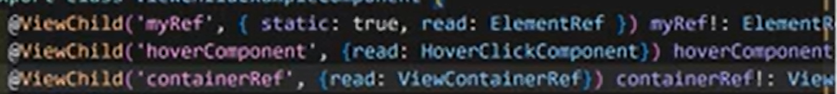  
  
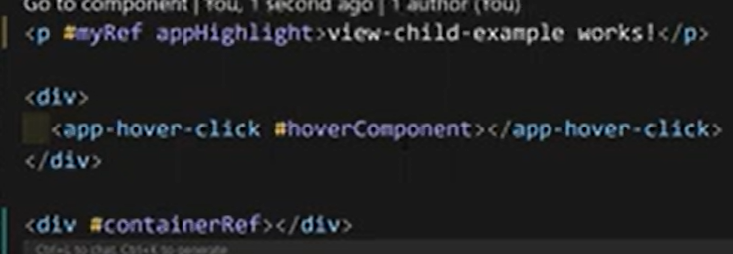

**Accessing multiple appeared elements  
  
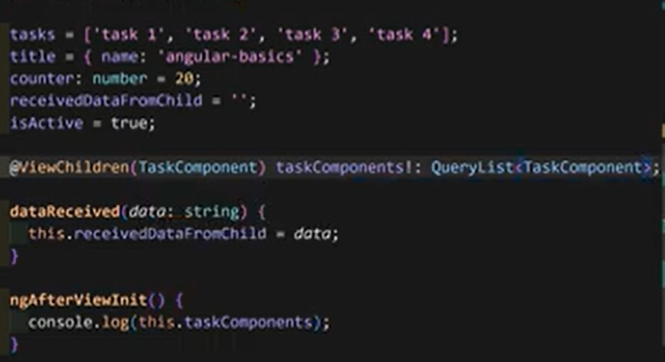**  
  
Reading as elementREf will give the all html element specification  
  
  
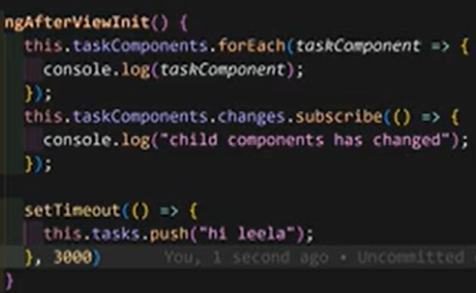  
  
  
  
  
  
  
**contentChild vs contentChildren**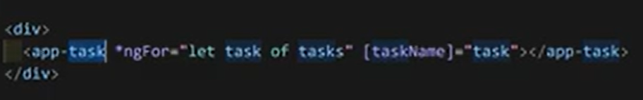

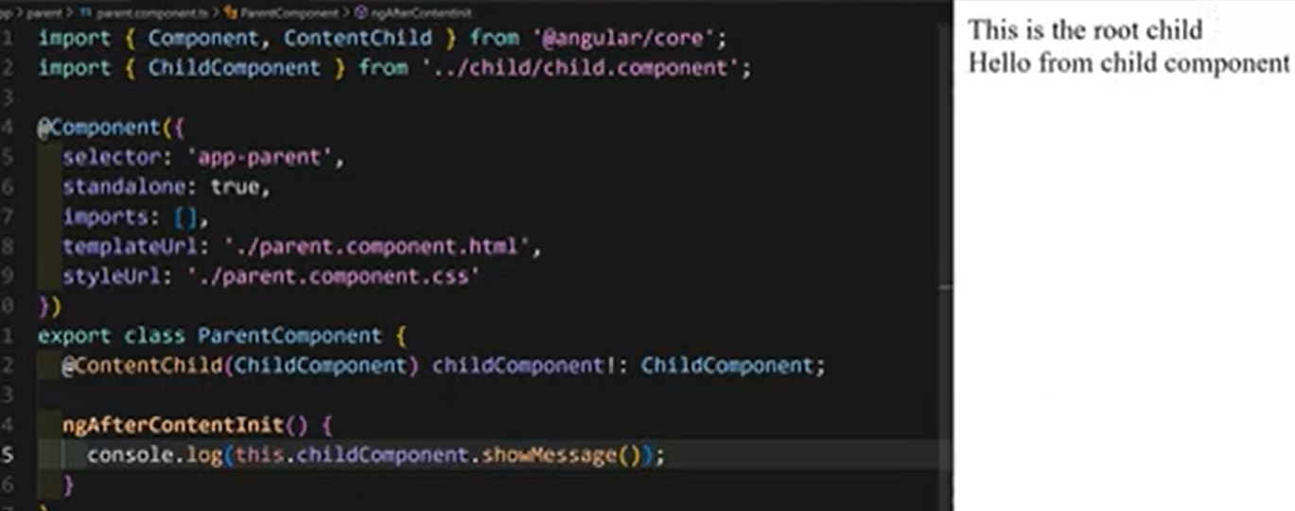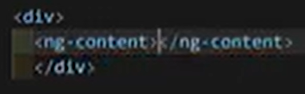

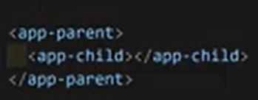



**Programmatically rendering components using ngComponentOutlet**

In Angular, you can dynamically render components in two primary ways: using the NgComponentOutlet directive in the template for simple scenarios, or using the ViewContainerRef class in TypeScript code for more programmatic control and complex use cases like lazy-loading or binding inputs/outputs

**Using NgComponentOutlet (Template-based)**

NgComponentOutlet is a structural directive that provides a simple, declarative way to render a component. It's useful when the component type to be rendered might change based on simple conditions.  
  
<p>Profile for {{user.name}}</p>

<ng-container

*ngComponentOutlet="getBioComponent();

inputs: greetingInputs;

outputs: greetingOutputs"

/>

import { Component, Input, signal } from '@angular/core';

import { AdminBioComponent } from './admin-bio.component';

import { StandardBioComponent } from './standard-bio.component';

@Component({

selector: 'app-custom-dialog',

templateUrl: './custom-dialog.component.html',

standalone: true,

imports: [NgComponentOutlet]

})

export class CustomDialogComponent {

@Input() user: any; *// Assume a user object with an isAdmin property*

*// Define inputs and outputs for the dynamic component*

greetingInputs = signal({ name: this.user.name });

greetingOutputs = {

*// Wire up an output event*

onRefresh: () => this.handleRefresh()

};

getBioComponent() {

return this.user.isAdmin ? AdminBioComponent : StandardBioComponent;

}

handleRefresh() {

console.log('Refresh event received from dynamic component');

*// Handle the event*

}

}

**Using ViewContainerRef (TypeScript-based)**

This method provides more granular control over the component lifecycle and its location in the DOM. It's ideal for scenarios requiring precise manipulation of the view or creating components from a service  
  
<button (click)="loadContent()">Load content</button>

*<!-- Anchor for dynamic components -->*

<ng-container #container></ng-container>

import { Component, ViewChild, ViewContainerRef, inject } from '@angular/core';

import { LeafContentComponent } from './leaf-content.component';

@Component({

selector: 'app-inner-item',

templateUrl: './inner-item.component.html',

standalone: true,

})

export class InnerItemComponent {

@ViewChild('container', { read: ViewContainerRef, static: true })

viewContainer!: ViewContainerRef;

*// For modern Angular, ComponentFactoryResolver is no longer needed*

*// We can directly use viewContainer.createComponent()*

loadContent() {

*// Clear any previous components from the container*

this.viewContainer.clear();

*// Create the component and attach it to the view container*

const componentRef = this.viewContainer.createComponent(LeafContentComponent);

*// Access the component instance to set inputs or subscribe to outputs*

componentRef.instance.someInput = 'some value';

componentRef.instance.someOutput.subscribe(event => {

console.log('Output event:', event);

});

}

}

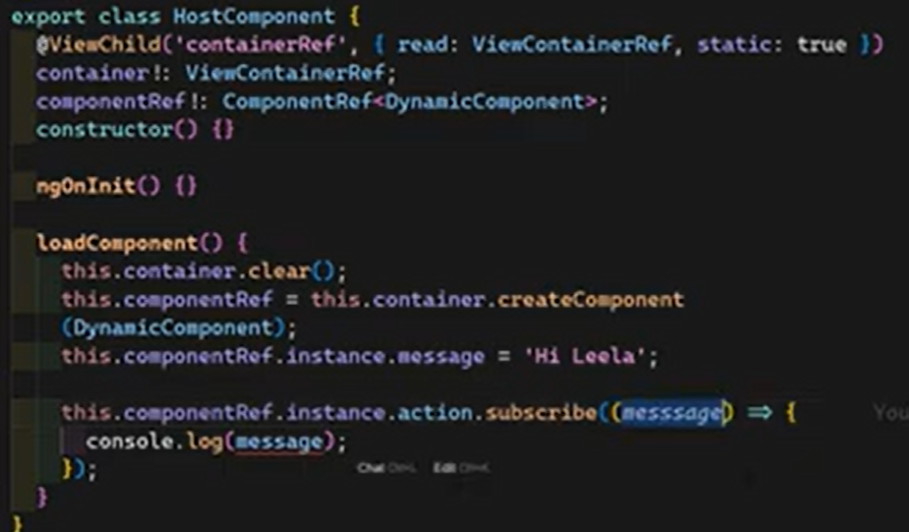

Lazyload component  
  
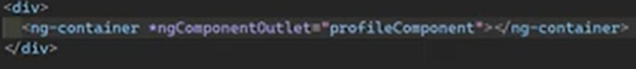

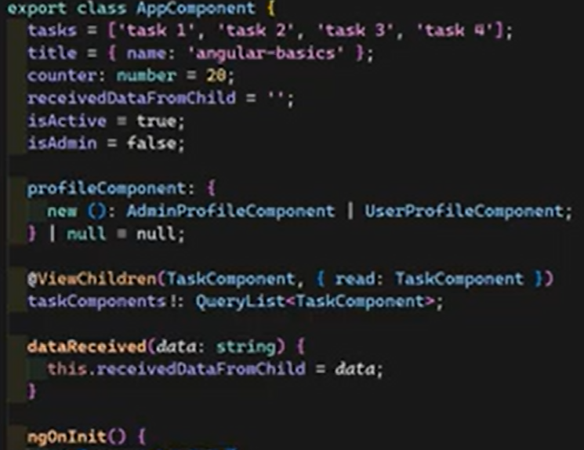

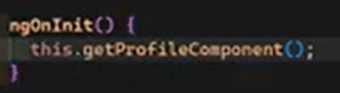

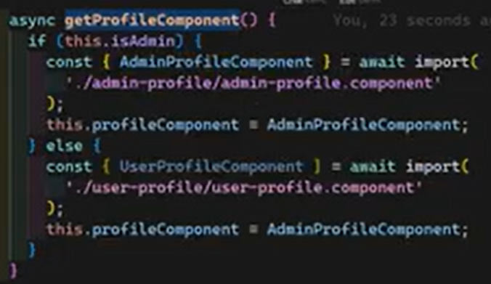

**Angular17's Change Detection Strategy: Default vs. onPush**

Angular provides two main change detection strategies: Default (or CheckAlways) and OnPush (or CheckOnce). The strategy determines how often Angular checks a component and its children for updates, with OnPush offering significant performance benefits.

**Default Strategy**

The Default strategy (used if no strategy is specified) is comprehensive but less performant for large applications.

* How it Works: Angular checks every component in the component tree from top to bottom whenever any change might have occurred in the application.
* Triggering Events: Change detection is automatically triggered by asynchronous events that are monkey-patched by Zone.js, such as:
  + DOM events (clicks, keyup, etc.)
  + HTTP requests
  + JavaScript timers (setTimeout(), setInterval())
* Behavior: It performs "dirty checking," comparing current template expression values with previous values for all components to ensure the UI is in sync with the model, even if only a small part of the application state has changed.

**OnPush Strategy**

The OnPush strategy is an optimization technique that gives developers more control over when change detection runs for a component and its subtree.

* How it Works: Angular skips change detection for a component and its children unless one of the following conditions is met:
  + An @Input() property changes (Angular performs a shallow reference check: previousValue === currentValue is false).
  + An event is triggered from within the component or its children (e.g., a button click handled by a component method).
  + An observable linked to the component's template via the async pipe emits a new value (the async pipe calls markForCheck() internally).
  + Change detection is explicitly triggered manually using ChangeDetectorRef methods like markForCheck() or detectChanges().
* Benefits: This strategy significantly boosts performance by avoiding unnecessary checks in large component trees. It encourages the use of immutable data structures or observables to ensure changes are detected correctly.
* Implementation: To use it, set the changeDetection property in the component's decorator:

@Component({

selector: 'app-on-push',

templateUrl: './on-push.component.html',

changeDetection: ChangeDetectionStrategy.OnPush, *// Set the strategy here*

})

**Zoneless Change Detection (Modern Angular)**

With the introduction of signals, modern Angular (v17.1+) is moving towards a zoneless architecture. This approach moves away from relying on Zone.js to detect all asynchronous operations and instead uses explicit notifications when a signal used in a template is updated. This allows for highly optimized, "semi-local" change detection where only the specific components affected by a change are re-rendered, further enhancing performance.

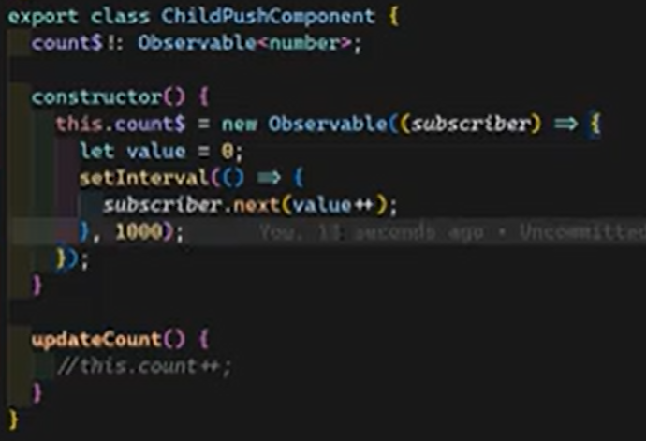  


**Template Expressions & Context in Angular 18**

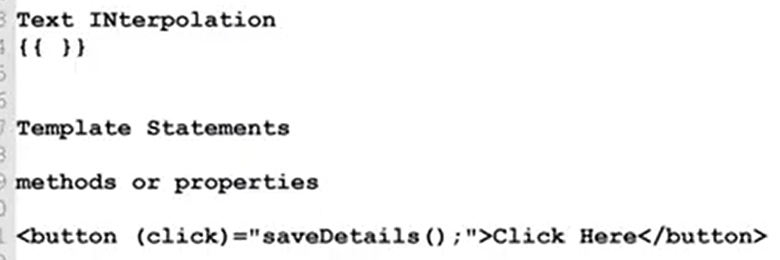

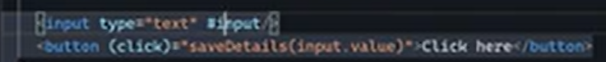  
  
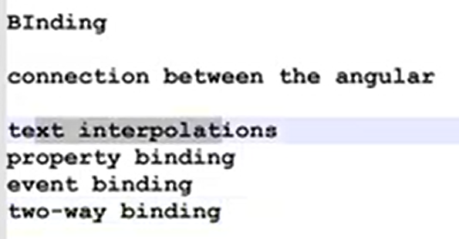

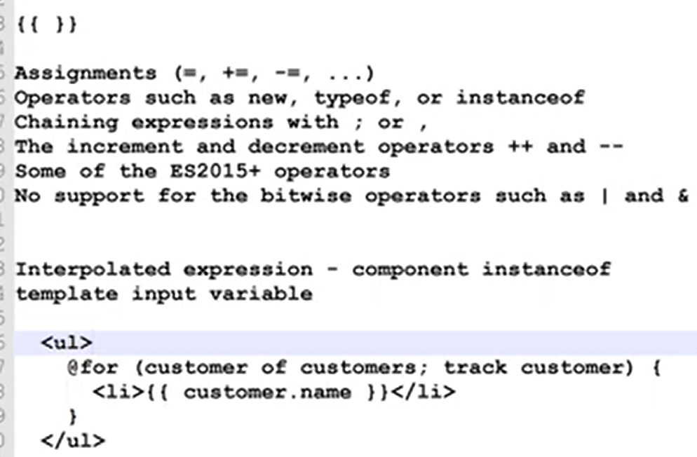

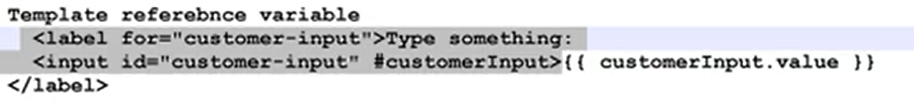

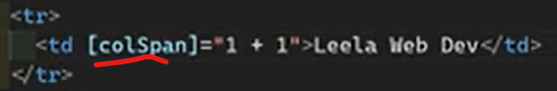

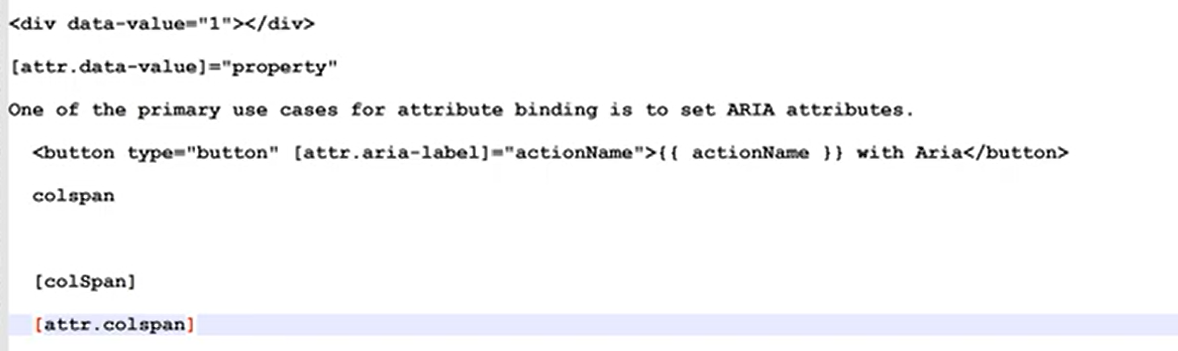

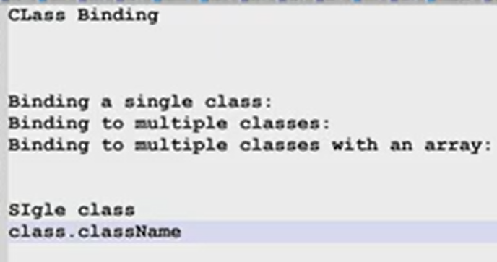  
  
isActive = true in ts file  
  
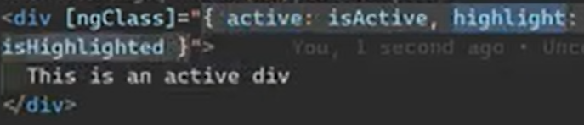  
  
  
  


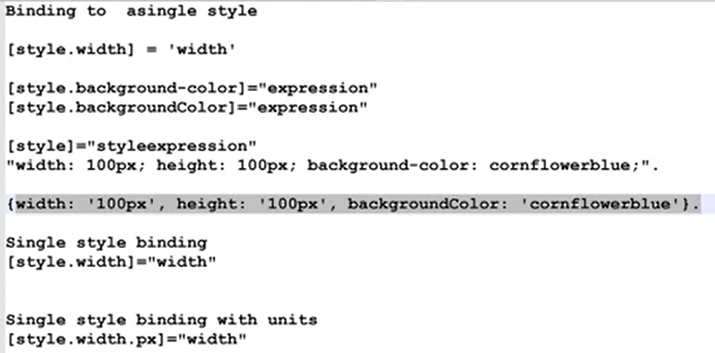

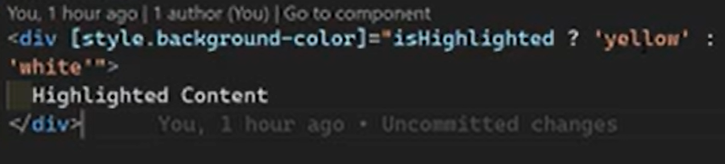

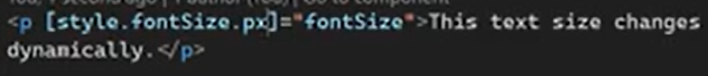  
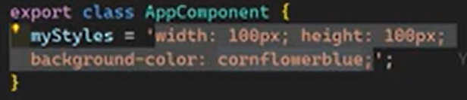  
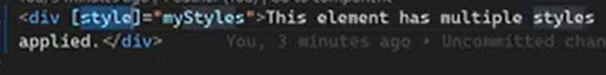

**Event binding**  
  
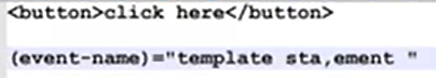

**Two way data binding**  
  
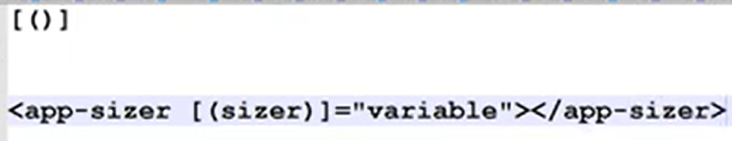 Property bind + event binding  
  
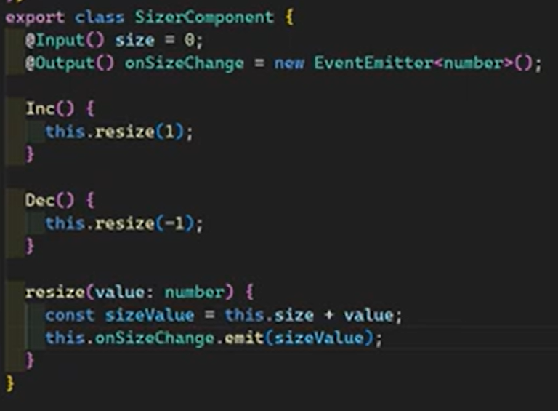  
  
Two way binding solution for the above example:   
  
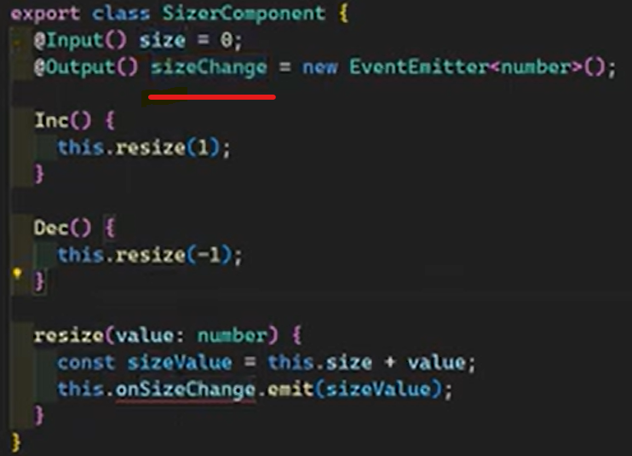 this event emitter must be follow this convention(<input>Change)  
  
  
  
  
  
  
  
  
  
  
  
  
  
  
  
  
  
  
  
  
**Angular 18 Control Flow: Using If and For Loop Effectively**Older style  
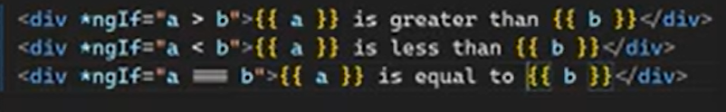  
  
Modern style  
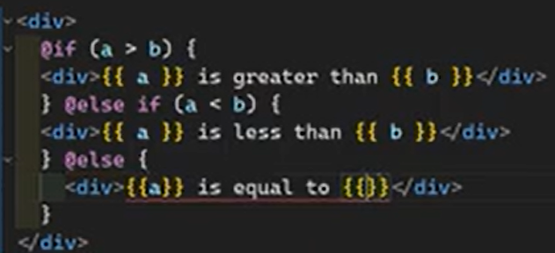  
  
  
  
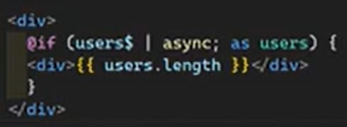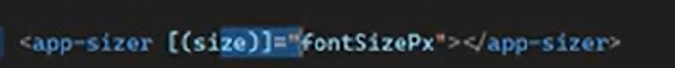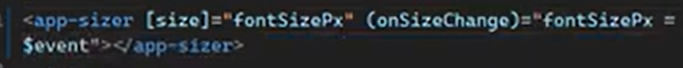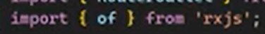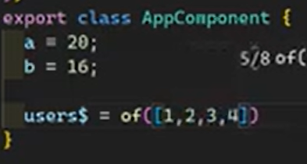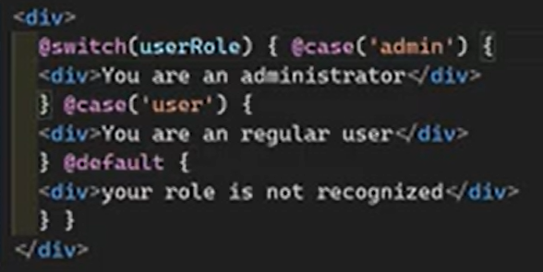

This track value should be unique value. Used as a unique key to dom elements  
  
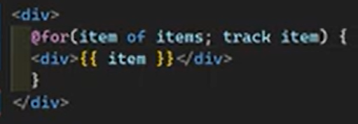  
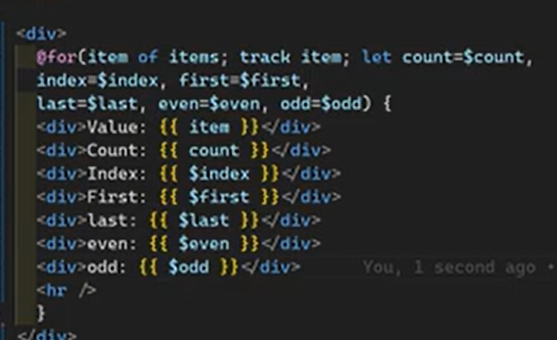  
  
  
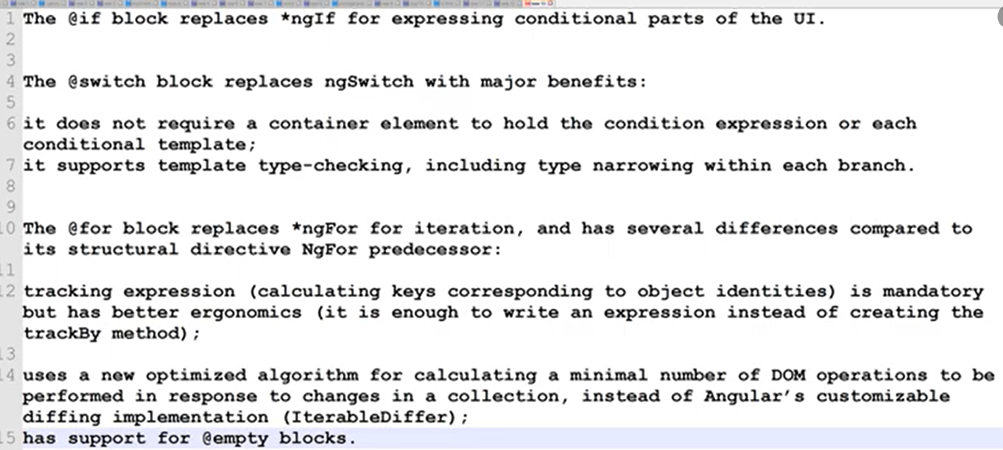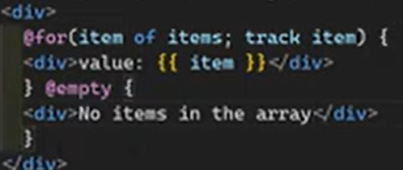

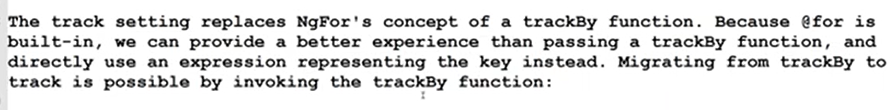  
  
  
**Local template variables let and its usage in angular Template developer preview**  
  
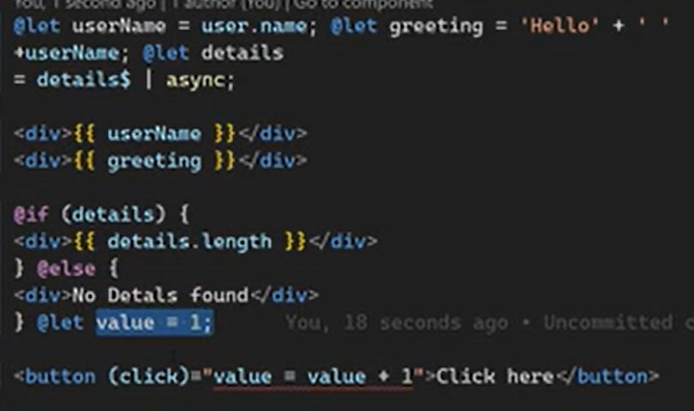

**Pipes**

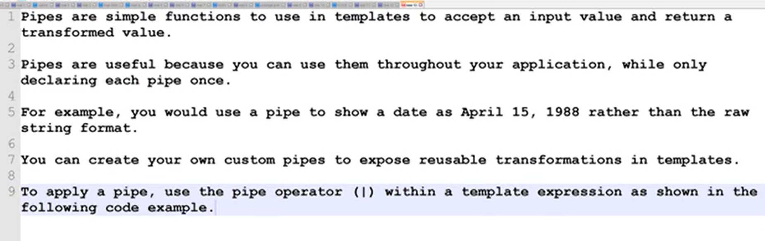

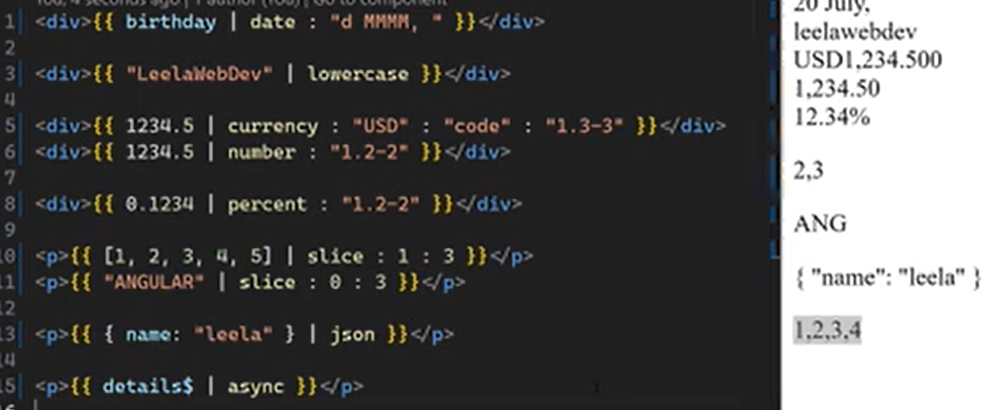

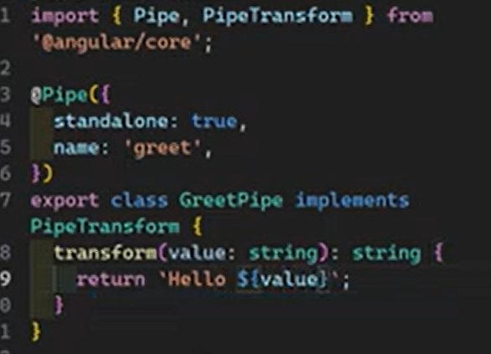  
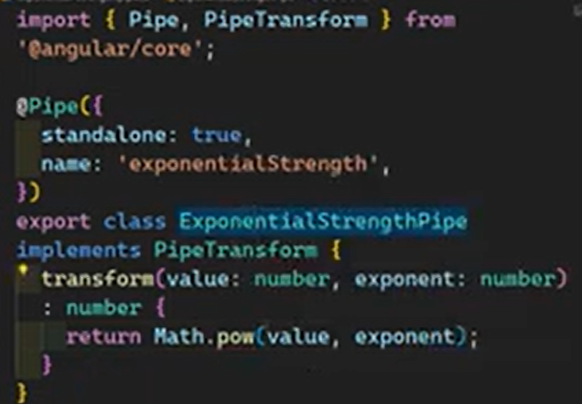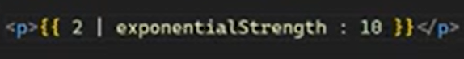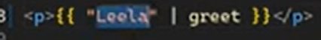

**Directives**

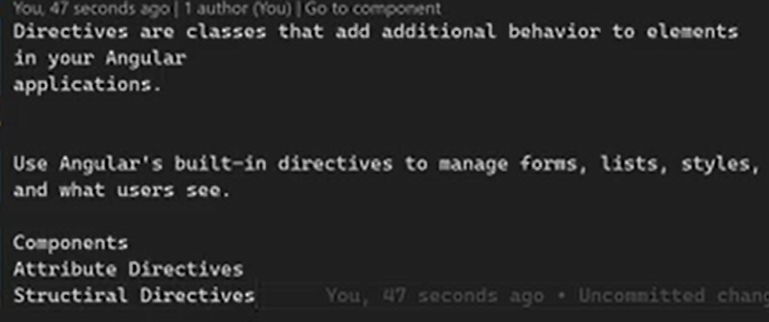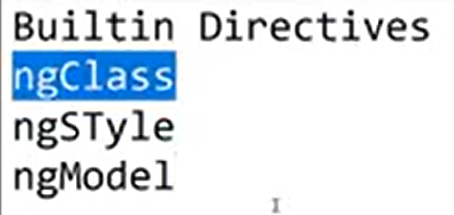

**Custom directives**  
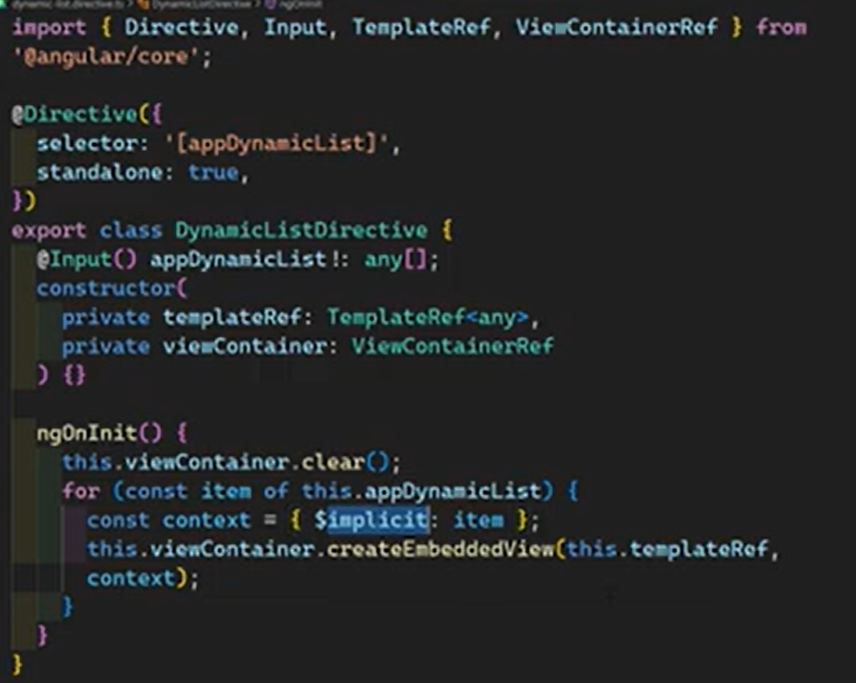

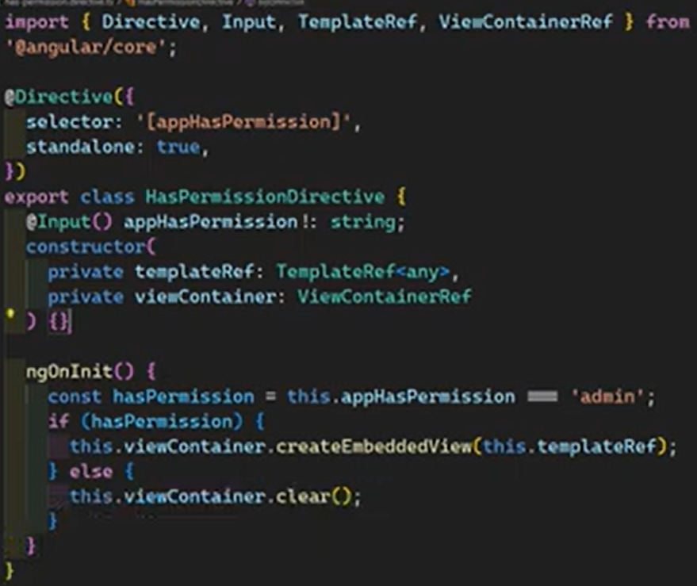

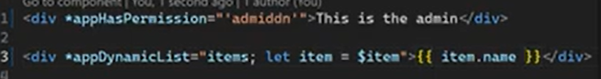  
  
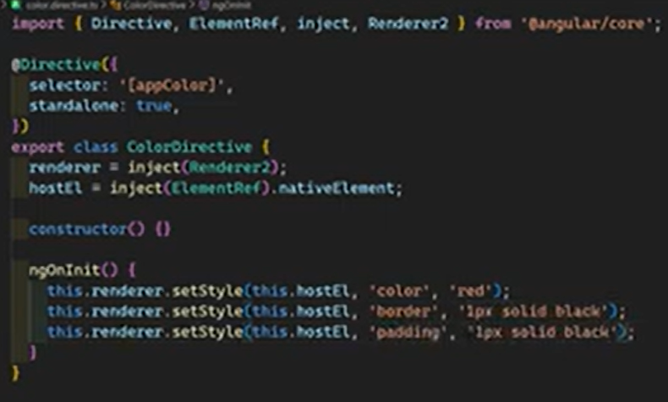

Leveraging two directives  
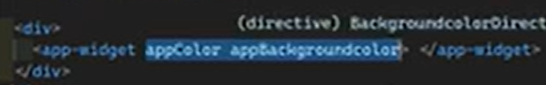  
We can use host directives (directive composition)  
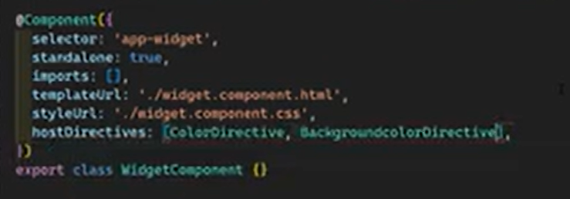

Making reusable directives

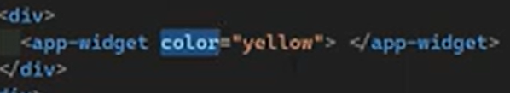  
  
  
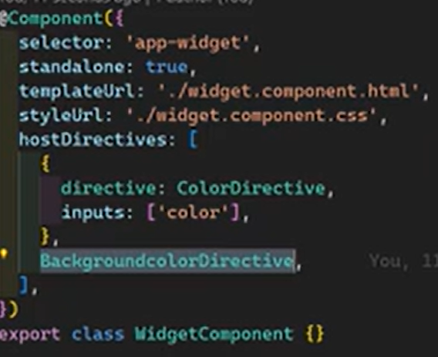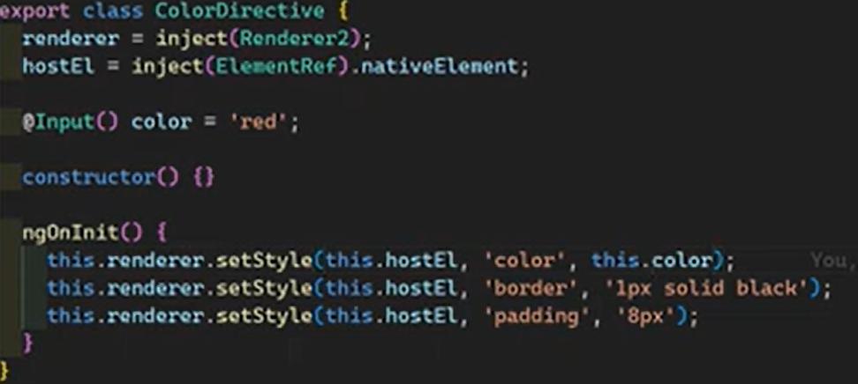

Events  
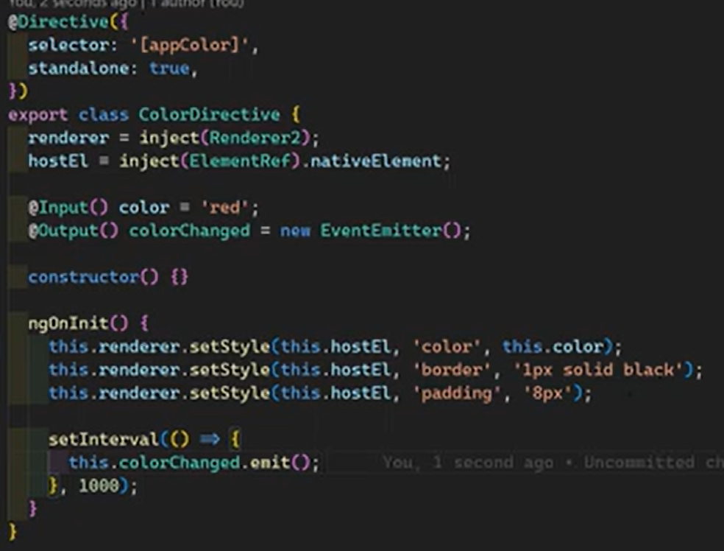  
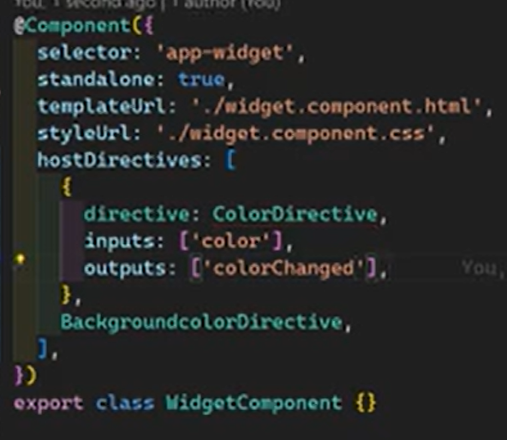

**Angular 18 Dependency Injection**  
  
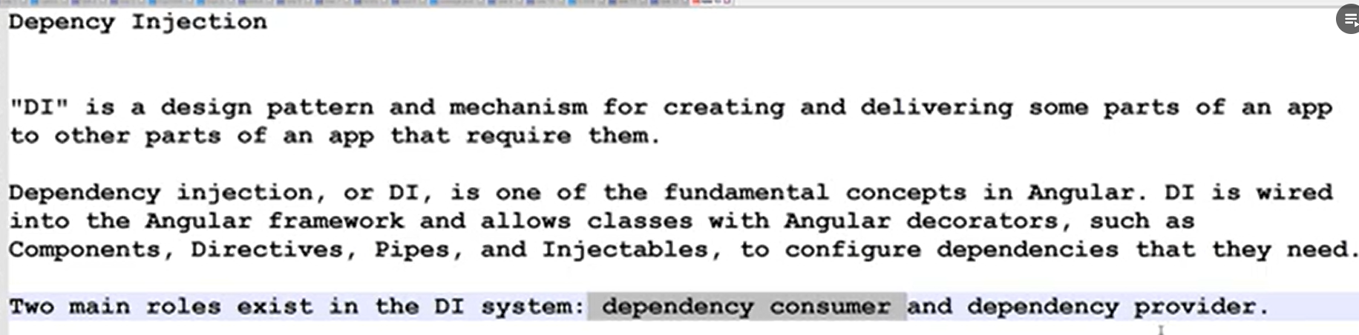  
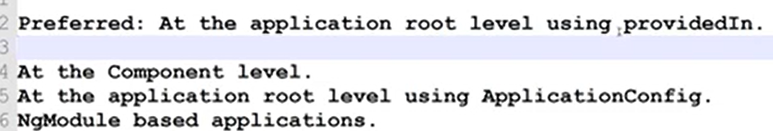  
  
**Providing dependecy**  
  
At the application root level using providedin  
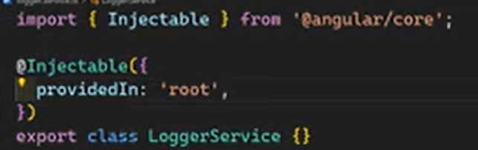single shared instance  
  
At the component level  
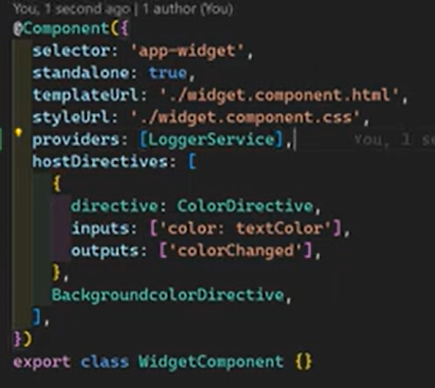instance for this component and its child components  
  
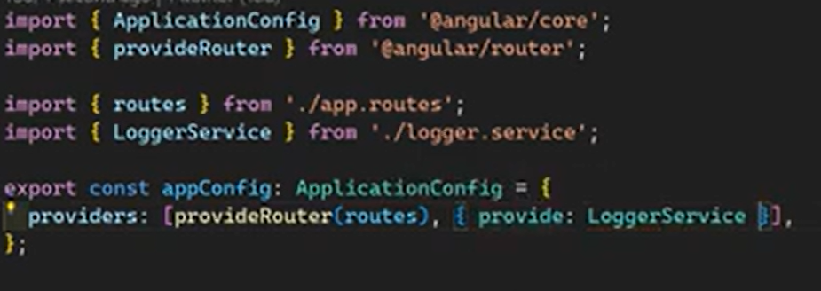rootlevel using application config  
  
  
 **Consuming dependencies**

constructor method 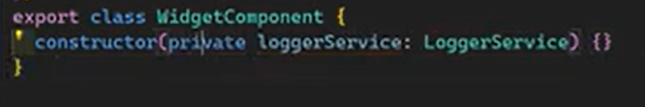Inject method 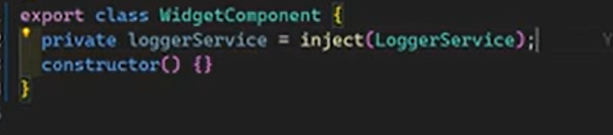

**Using useClass in standalone components —---------------------------------------------------------------------**Providers: [LoggerService]  
  
Expanded version >>>>>  
  
  
  
useClass, useExisting, useFactory, useValue  
  
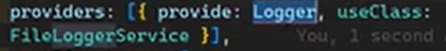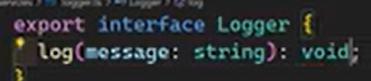

**Best practices for using interfaces**  
  
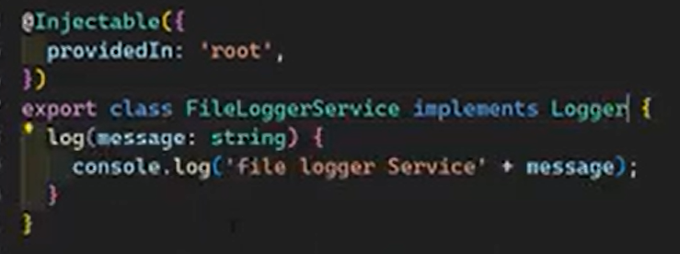  
  
  
**useFactory for Dynamic Dependency Injection —-------------------------------------------------------  
  
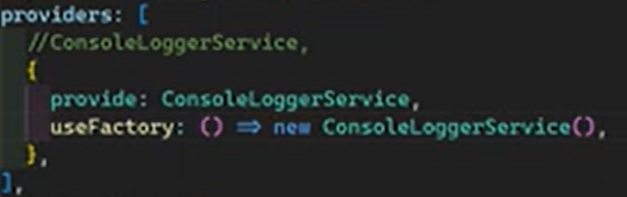  
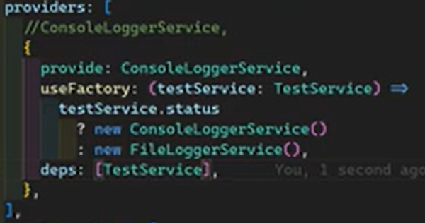**conditionally injecting services  
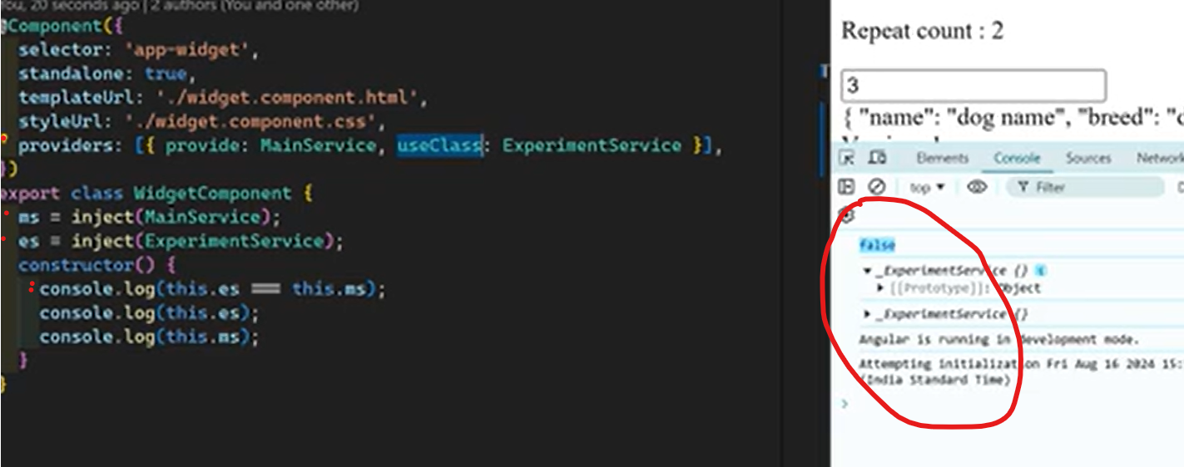  
  
**useValue and useExisting —-------------------------------------------------------------------------------**  
  
  
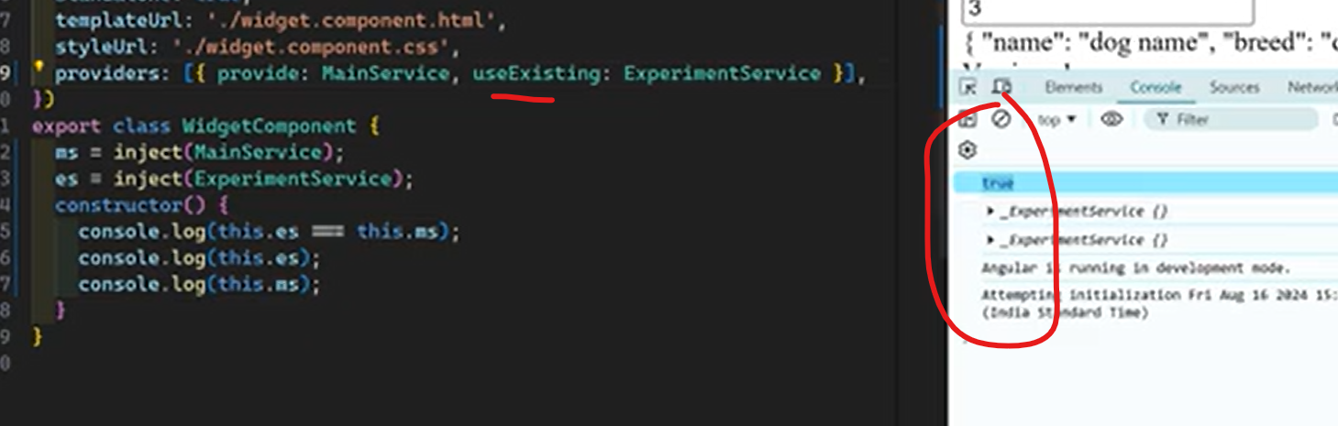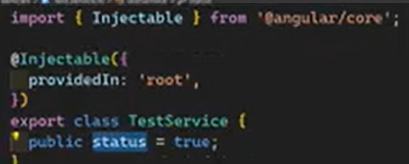

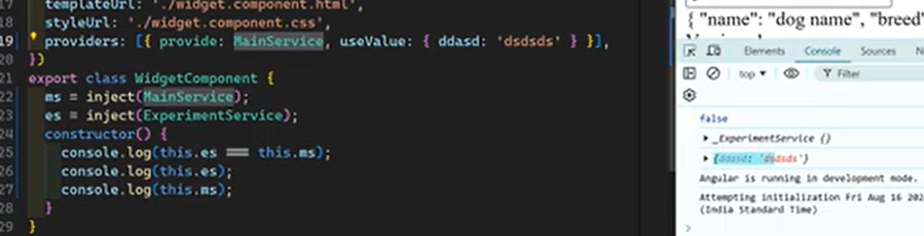

**Injection Context in Angular 18: Understanding Different Runtime Contexts**

The injection process happens at runtime context. Most of the time up to now we have injected services in constructor of any specific class, component or service  
As well as we have seen the service factory  
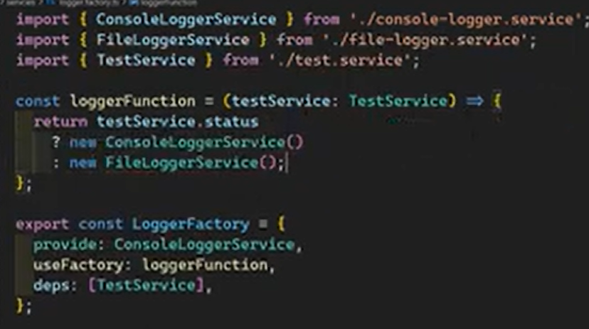

Using tokens  
  
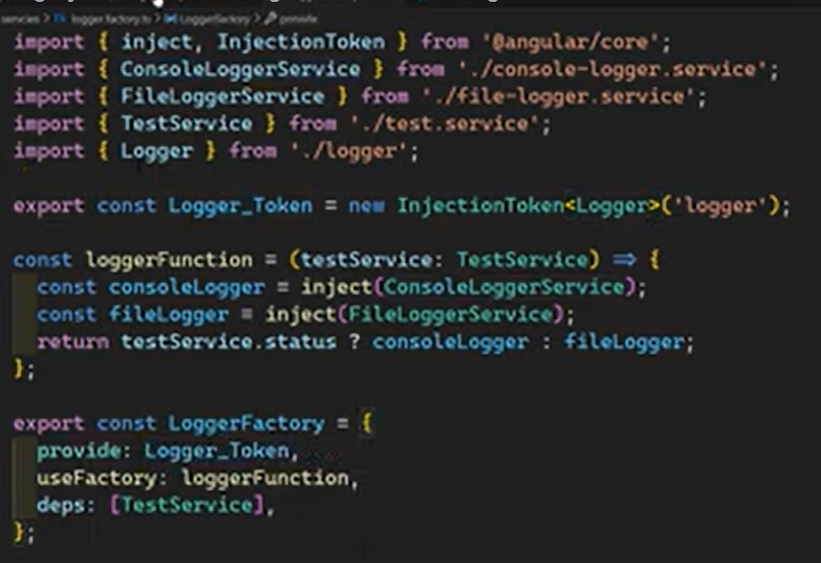  
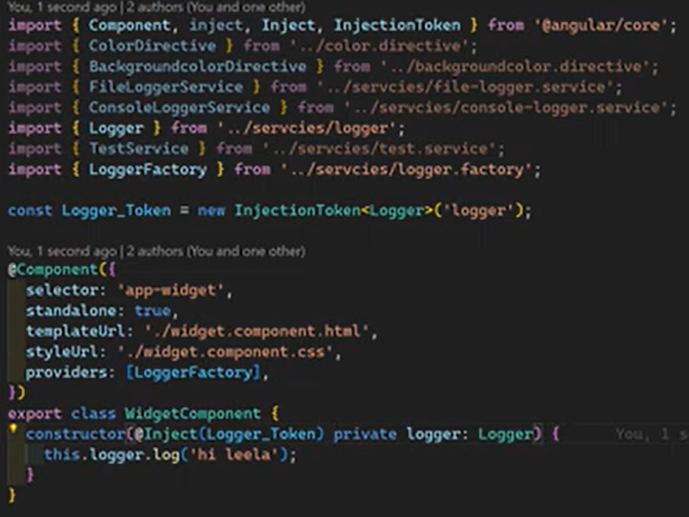

**Routes  
  
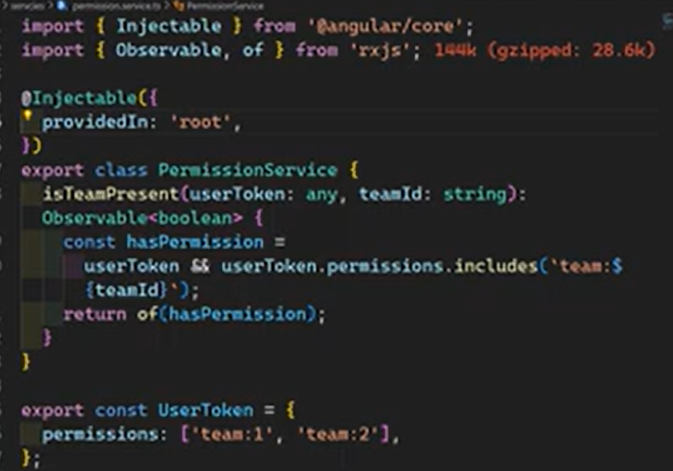  
  
  
  
  
  
  
Continue upto part 82….  
Signals**Angular Signals are a system that granularly tracks how and where your state is used throughout an application, allowing the framework to optimize rendering and improve runtime performance. Introduced in Angular 16 and expanded in subsequent versions (including v19 in late 2024 and v20 in 2025), they provide a simpler, synchronous reactive model compared to RxJS  
  
**Core Concepts and Primitives**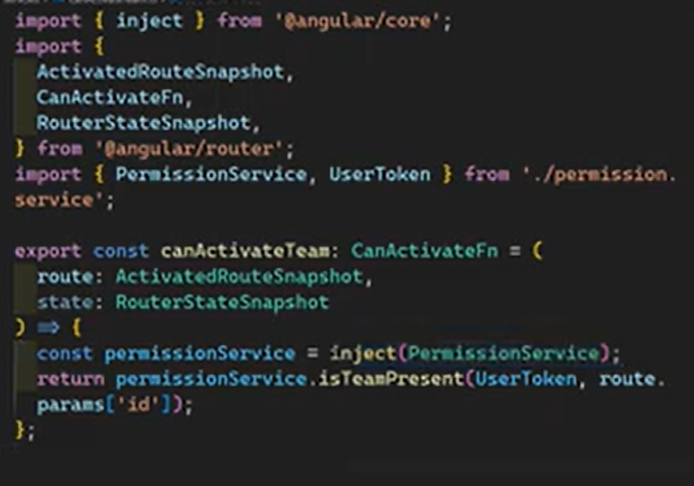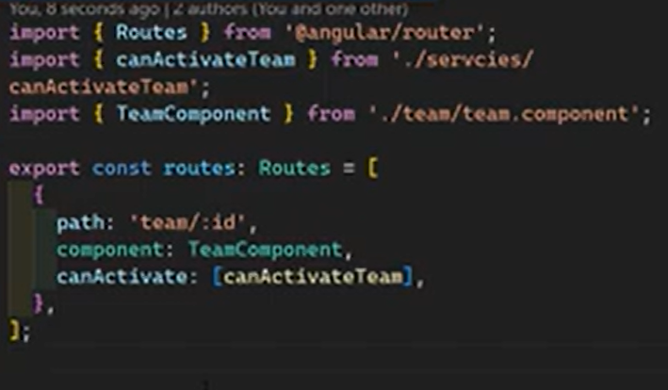

* Writable Signals: Create a signal with an initial value. You can change its value directly using .set(newValue) or .update(current => newValue).

**const count = signal(0);**

**count.set(1); *// Explicitly set to 1***

**count.update(v => v + 1); *// Increment to 2***

Computed Signals: Read-only signals derived from other signals. They are lazily evaluated and memoized, meaning they only re-calculate when their dependencies change and are accessed.

* Effects: Functions that run whenever the signals they depend on change. These are typically used for side effects like logging, manual DOM manipulation, or syncing with local storage.
* Signal Inputs & Queries: Modern alternatives to @Input, @ViewChild, and @ContentChild that treat incoming data and DOM queries as signals for better reactivity.
* Resource API: Introduced in newer versions (v19/v20) to handle asynchronous operations, like fetching data from a server, directly within the signal system.

**Why Use Signals?**

1. Fine-Grained Reactivity: Unlike standard change detection that may check the entire component tree, signals allow Angular to update only the specific parts of the UI that depend on changed data.
2. Performance: They reduce the reliance on zone.js, leading to faster runtime execution and smaller bundle sizes in "zoneless" applications.
3. Predictability: Signals are strictly synchronous and always have a value, avoiding the complexities of asynchronous data streams found in RxJS.
4. Integration with OnPush: Using signals in templates automatically marks OnPush components for check, simplifying manual change detection management.

**Best Practices**

* Avoid Mutating Objects Directly: When a signal holds an object or array, replace the entire value instead of mutating properties to ensure Angular detects the change.
* Prefer Computed over Effects: Use computed() for deriving data and save effect() for external side effects.
* Encapsulation in Services: Keep writeable signals private within services and expose them as read-only signals using .asReadonly() to control how state is modified.

**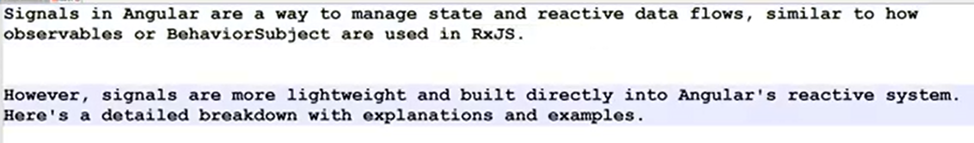  
  
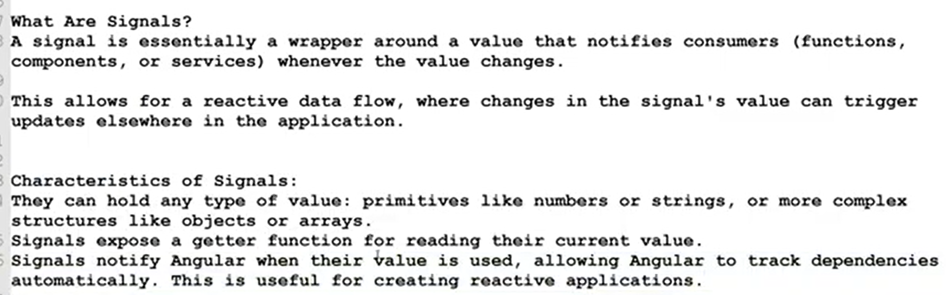  
  
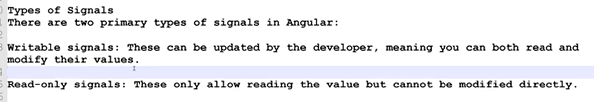  
  
export class Footer implements OnInit {**

**// countVal: number = 3;**

**countVal: WritableSignal<number> = signal(3);**

**ngOnInit(): void {**

**setInterval(() => {**

**this.countVal.update(val => val + 1)**

**}, 500)**

**}**

**}**

**<app-counter [count]="countVal"></app-counter>  
  
export class Counter {**

**@Input() count: any = 0;**

**}**

**<div>**

**current count value: {{ count() }}**

**</div>**

**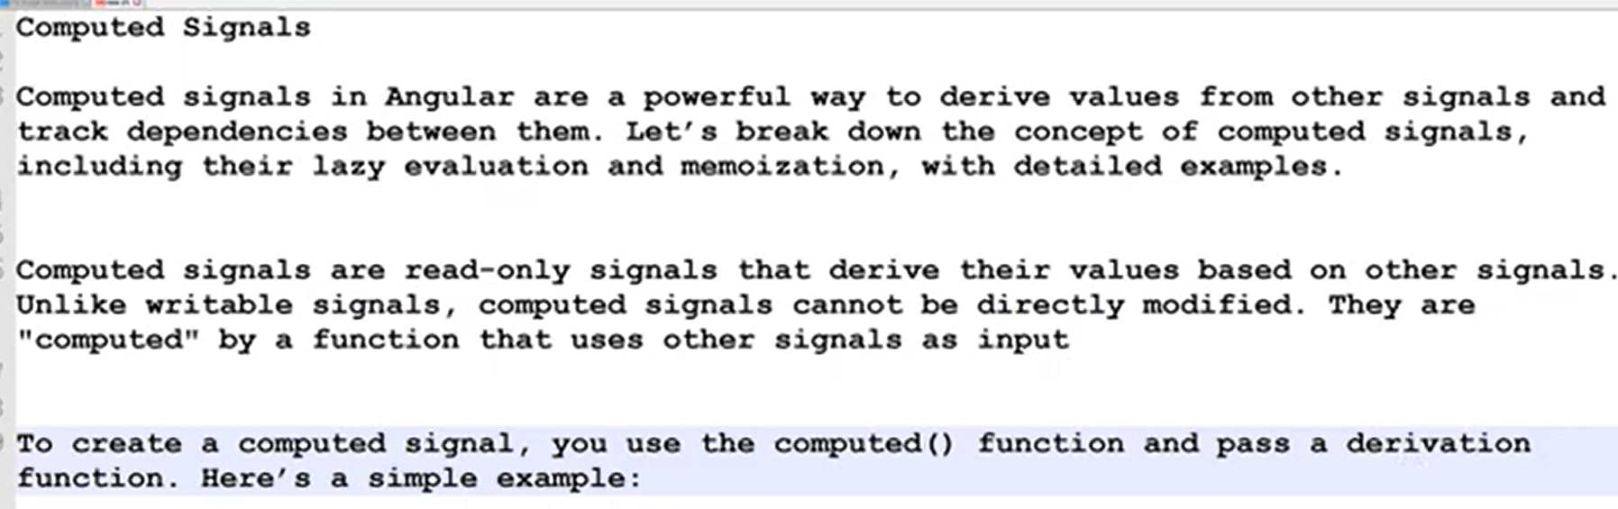  
  
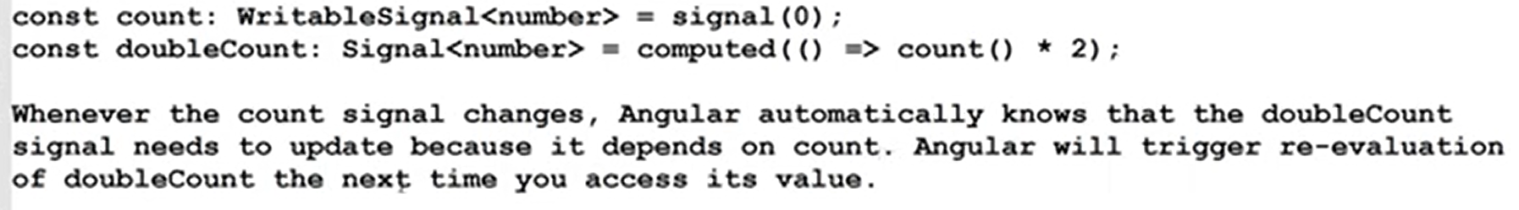  
  
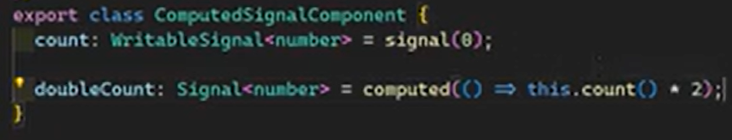  
  
  
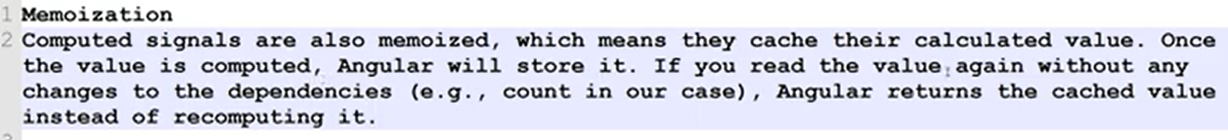  
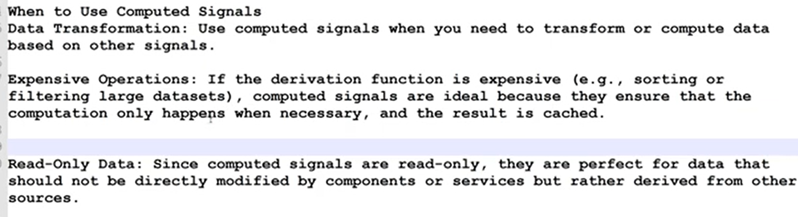  
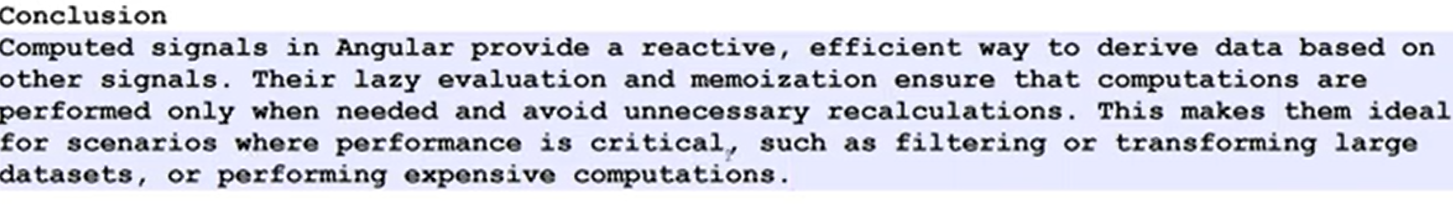**

**Dynamic Dependencies: Computed Signals  
  
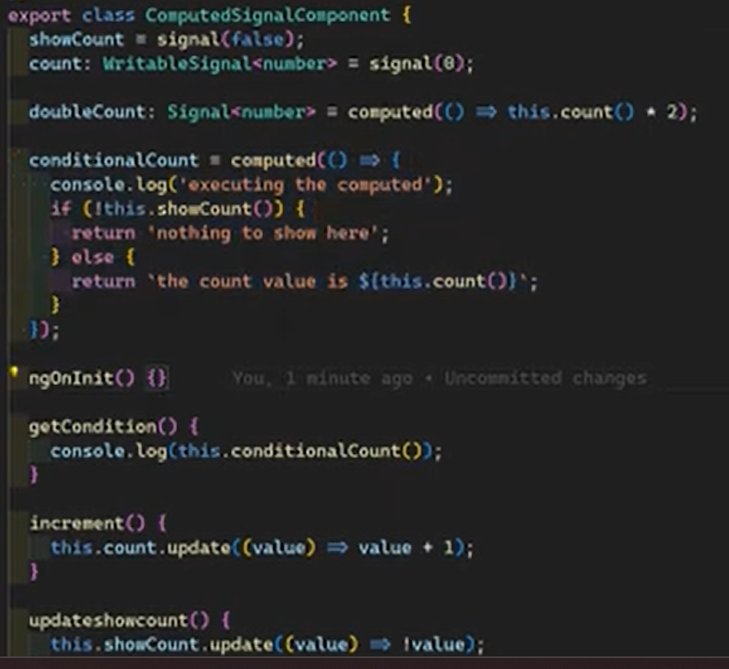**At the beginning conditional count executed once and evaluated, In there this.showcount is false and goes inside if block hence else block is not evaluated. Therefore at that time showcount is only the dependency for the computed signal. Afterwards if increment count happened any round the conditionalcount computed signal not evaluated since its dependency is only the showcount at this time   
  
Once the update show count is executed show count is updated (false -> true), then evaluated computed signal, then goes to the else block. Now the dynamic dependency is the count value. Now this signal computed function executed for always when the increment count happens

**Effects**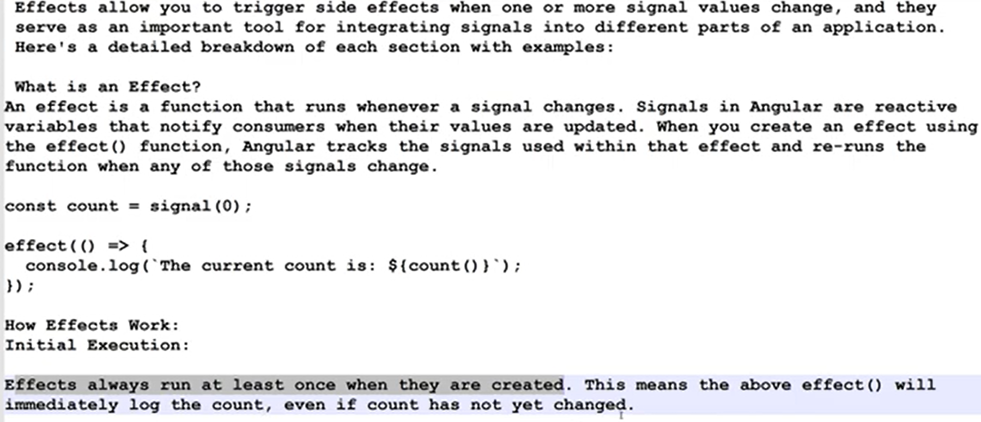  
  
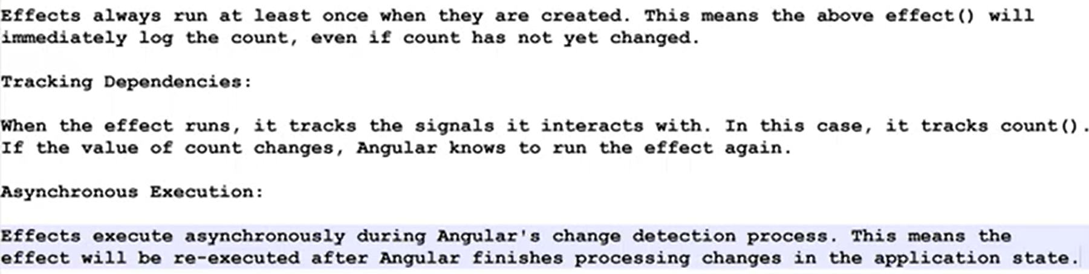  
  
  
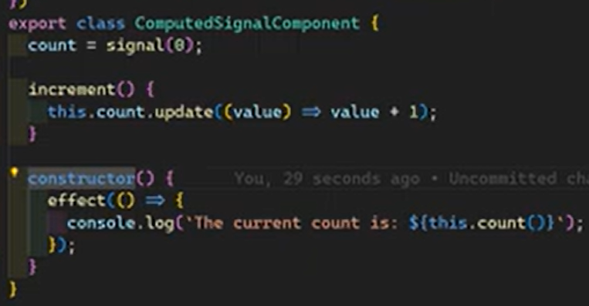  
  
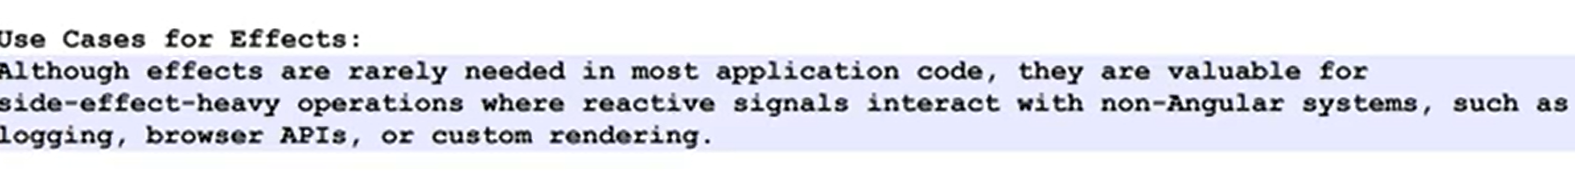  
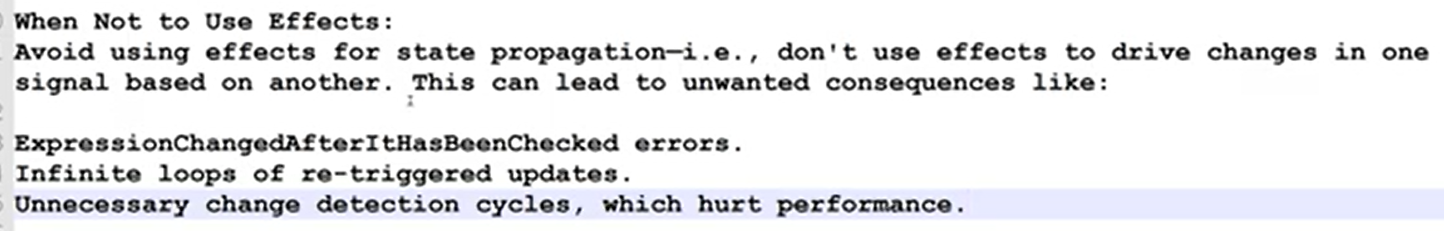  
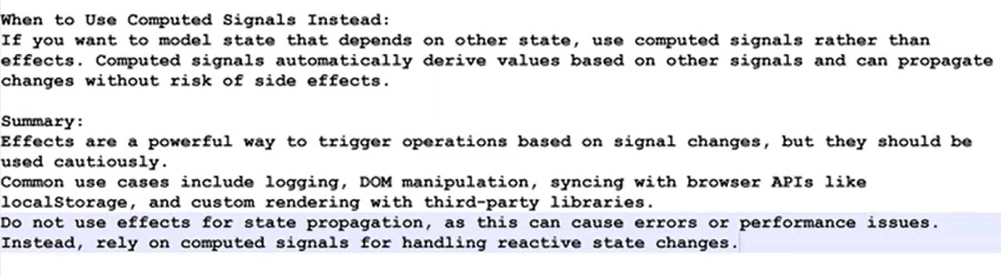  
  
  
**How to Create and Destroy Effects  
  
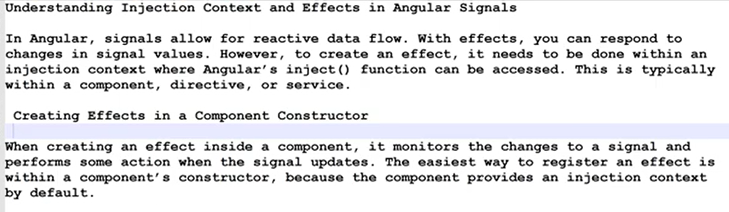  
  
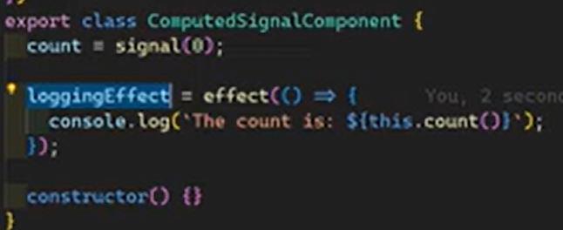  
  
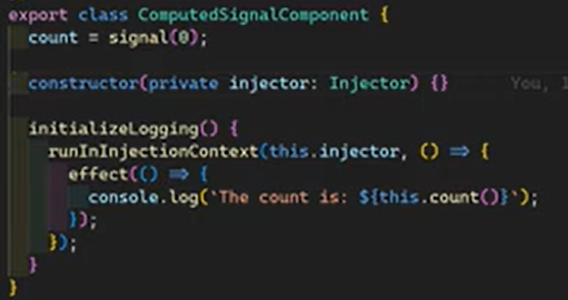** Creating effect outside from the inject context (this time constructor injection context) required to manually inject into the injection context  
  
  
  
  
  
**Equality functions —-----------------------------------------------------------------------------------------------**  
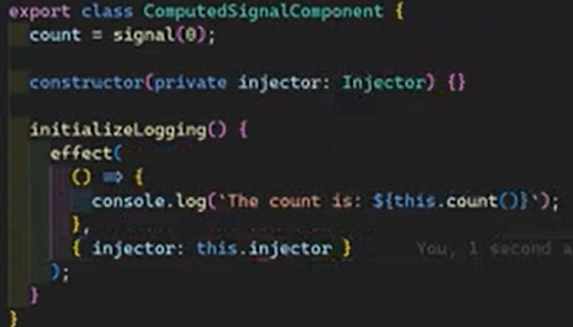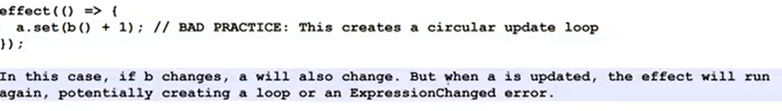

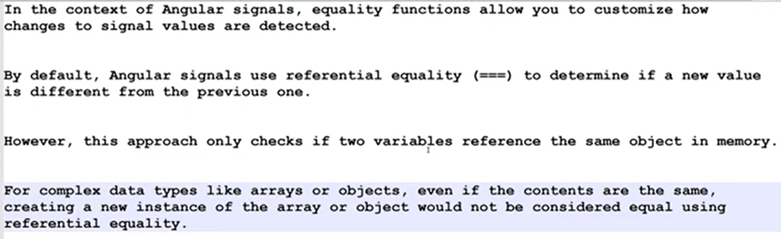  
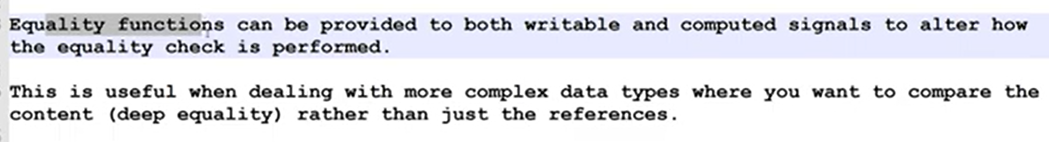  
  
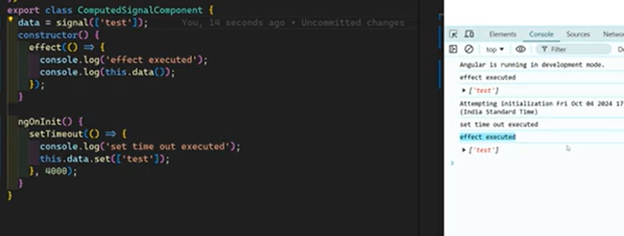  
Assigning same value ([“test”]) leads to execute effect once again since it creates new reference although it’s content is same as previous  
  
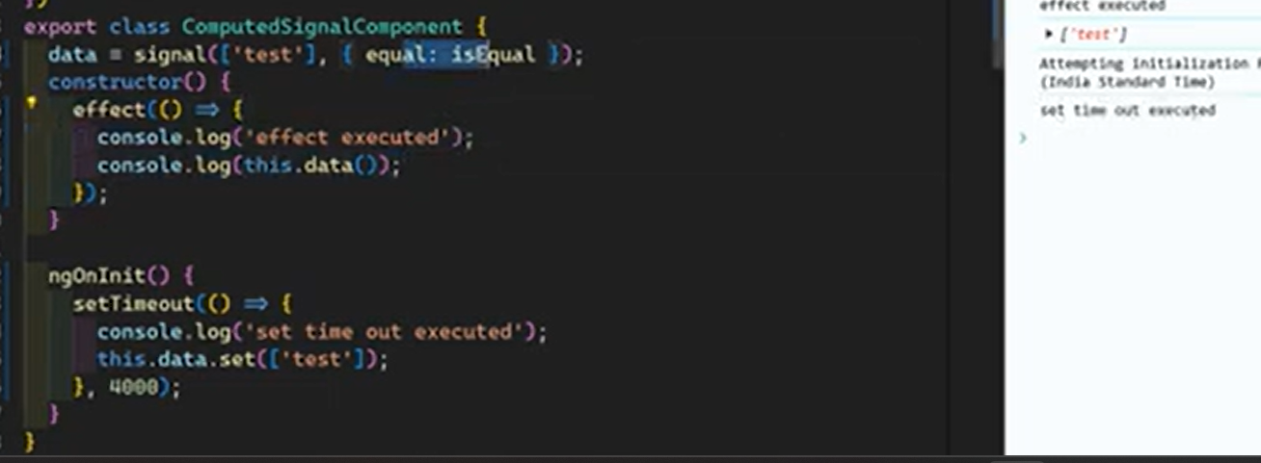  
Deep equality check with Loadsh isEqual function

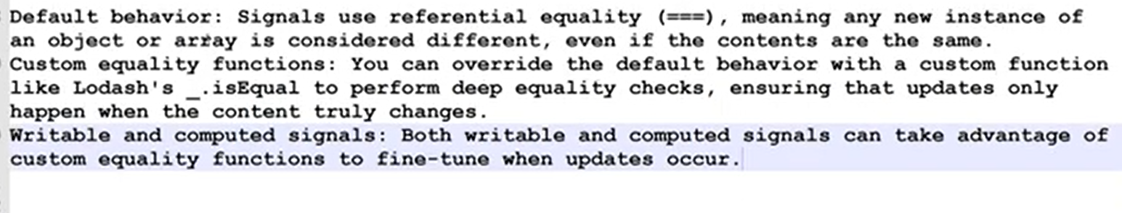

**Read Without Tracking Dependencies —---------------------------------------------------------------------**

**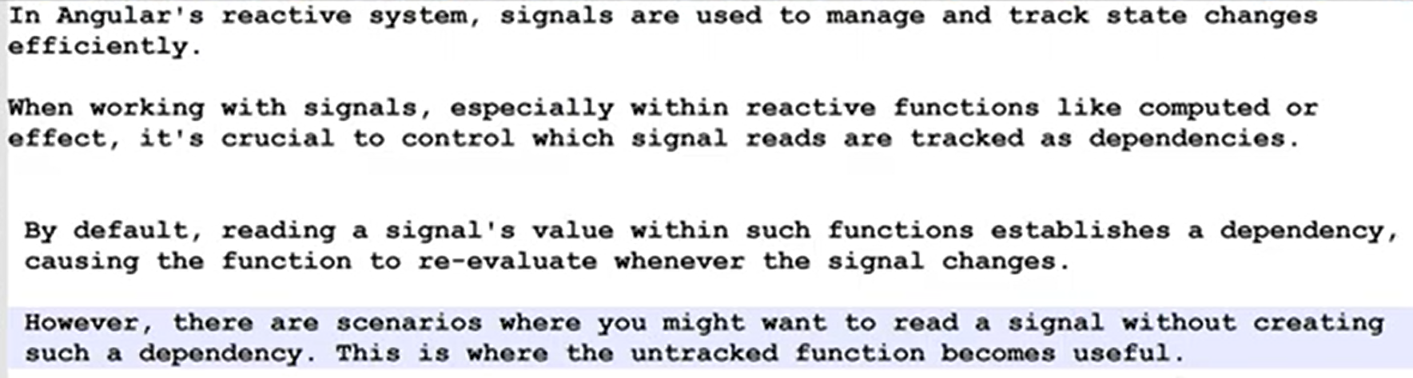  
  
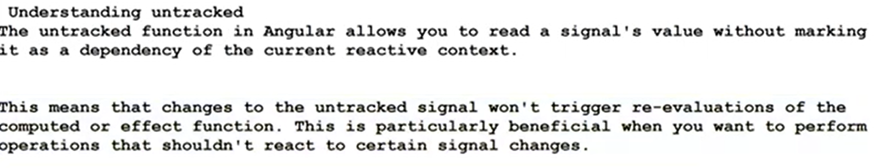  
  
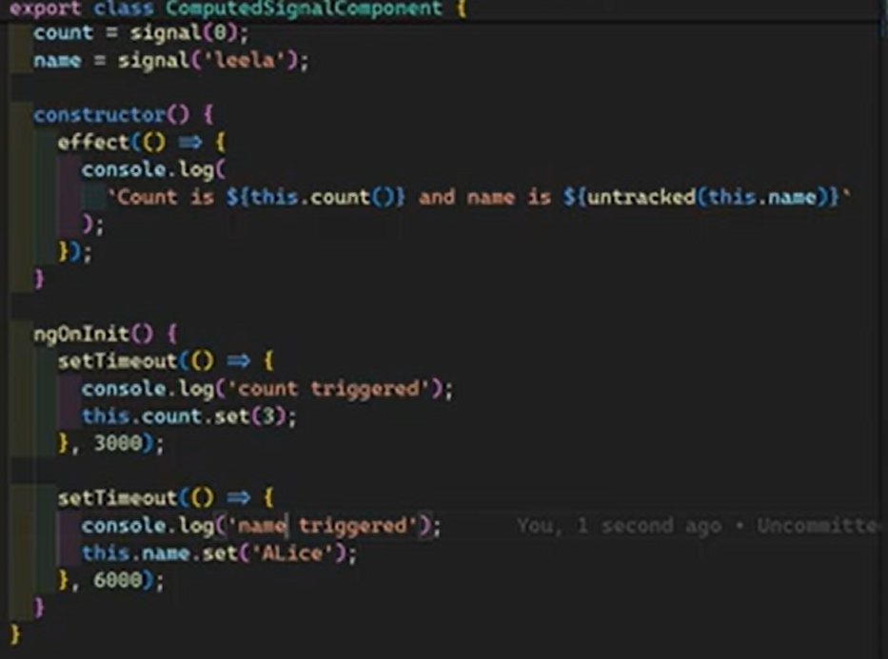**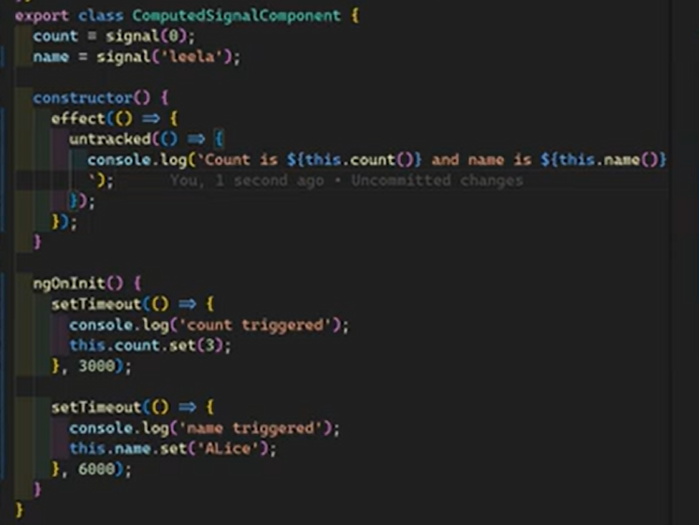

**Cleanups —----------------------------------------------------------------------------------------------------------  
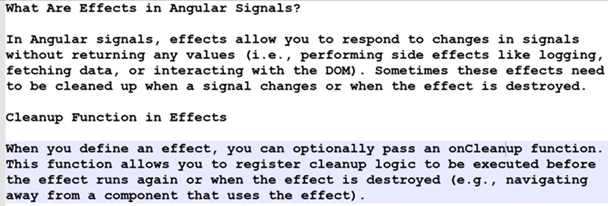**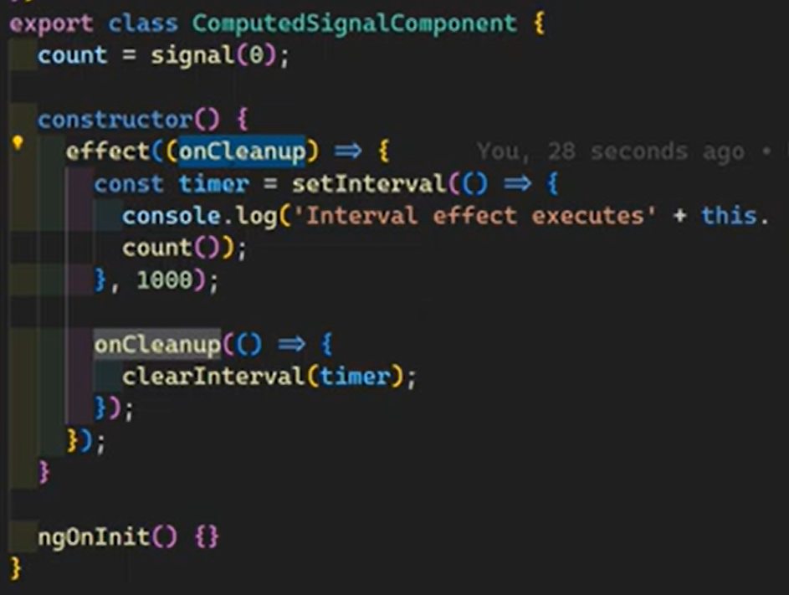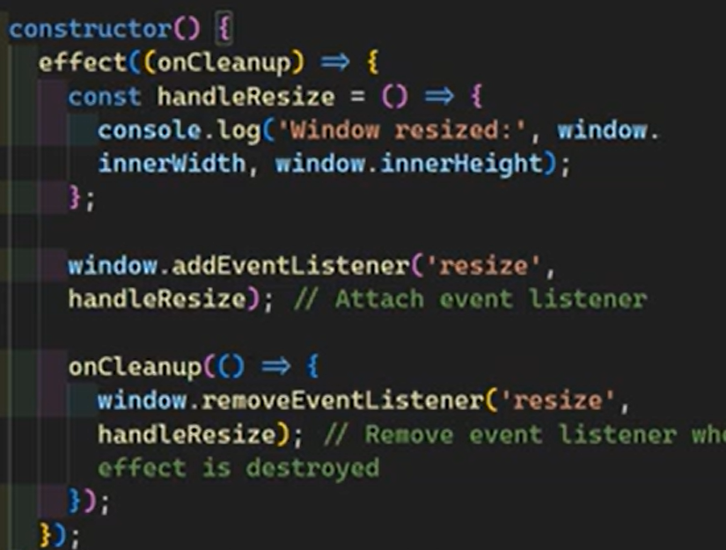

**Signals & RxJS Interop —----------------------------------------------------------------------------------------**

**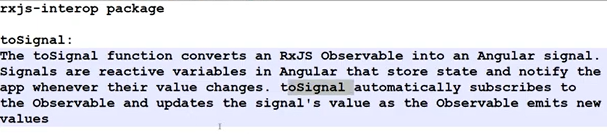  
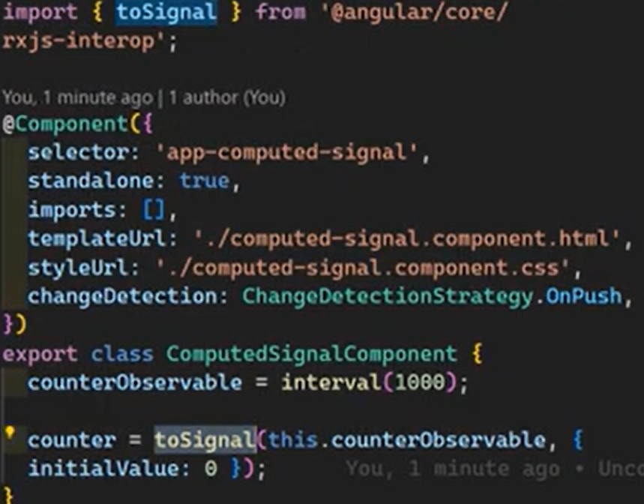  
  
  
  
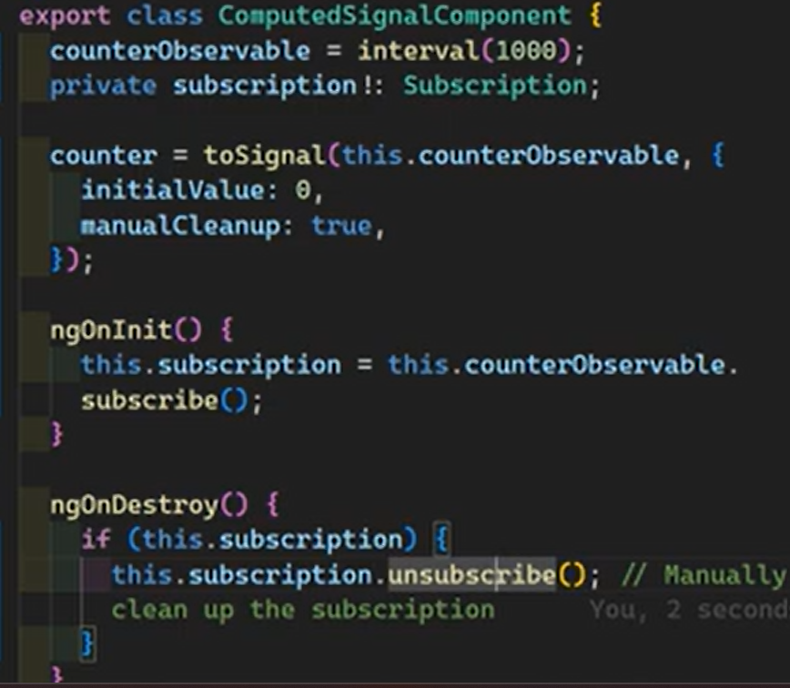  
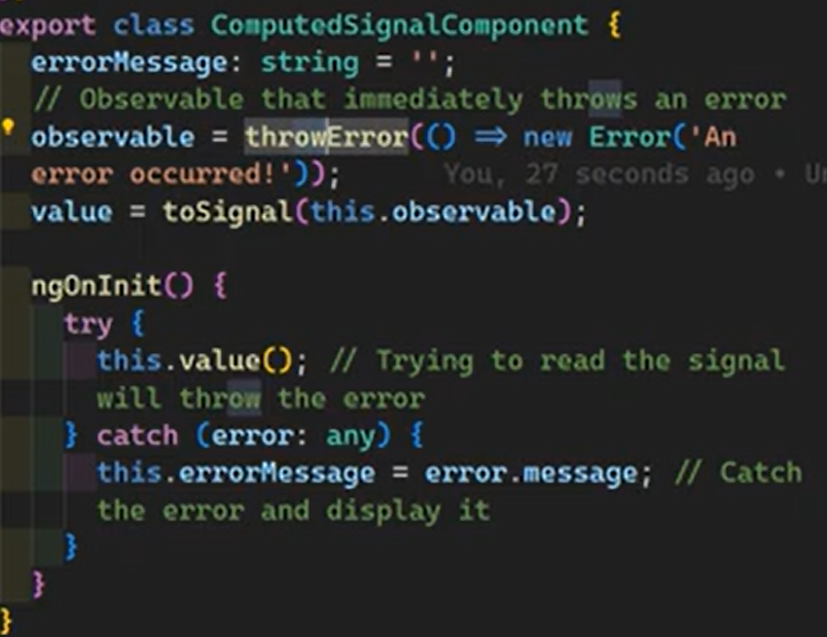**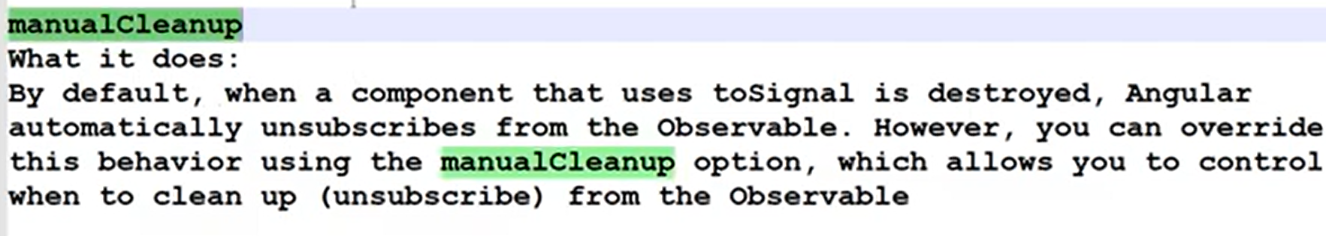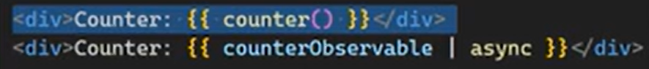

**toObservable —--------------------------------------------------------------------------------------------------------**

**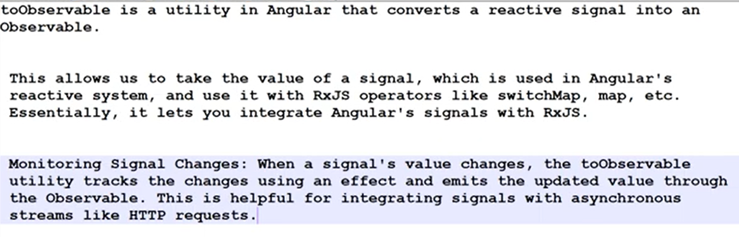  
  
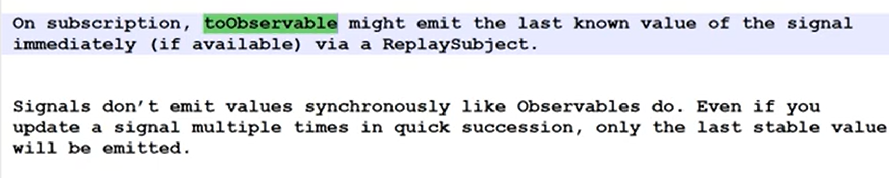  
  
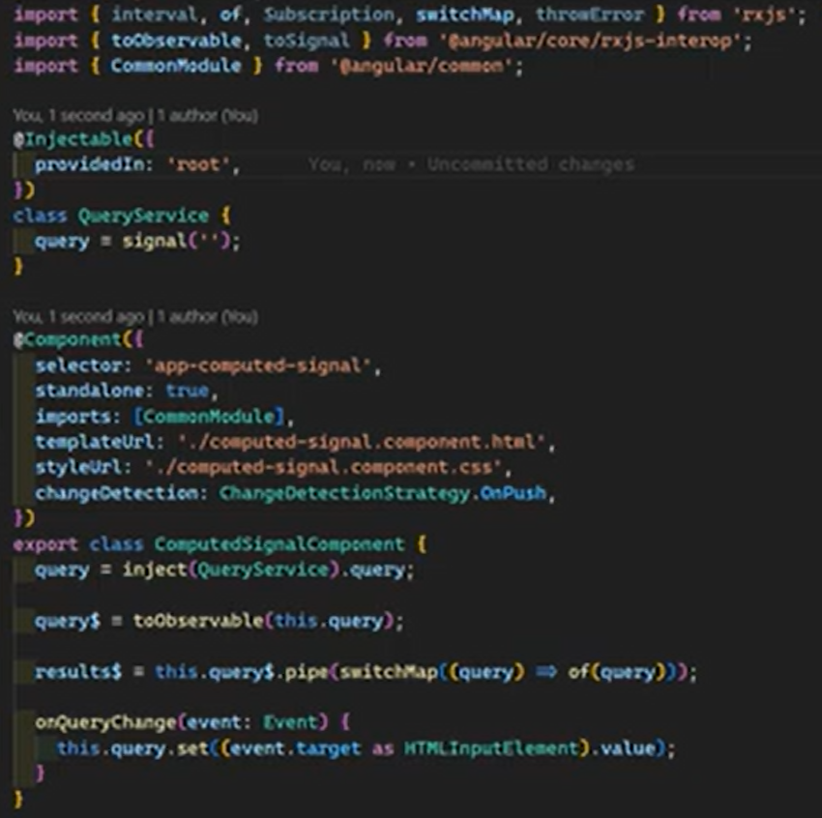  
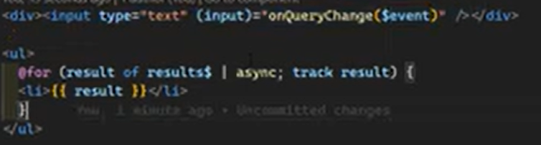**

**outputFromObservable / outputToObseravable —--------------------------------------------------------**

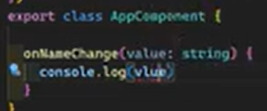

**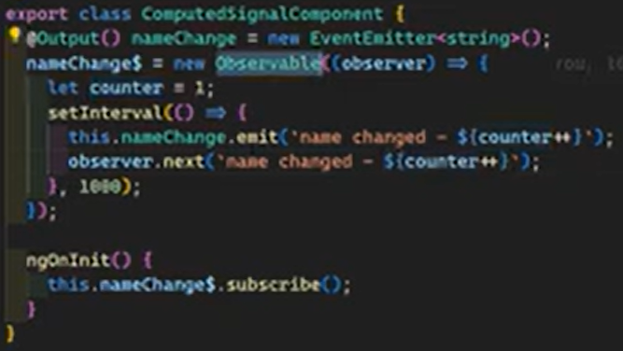  
**outputfromobserablbel **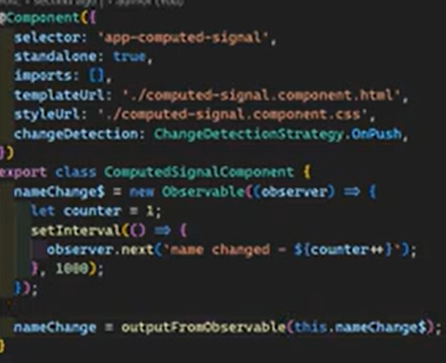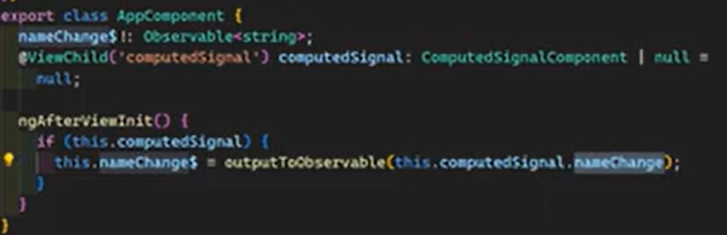  
  
  
  
Signal Input —----------------------------------------------------------------------------------------------------------**

**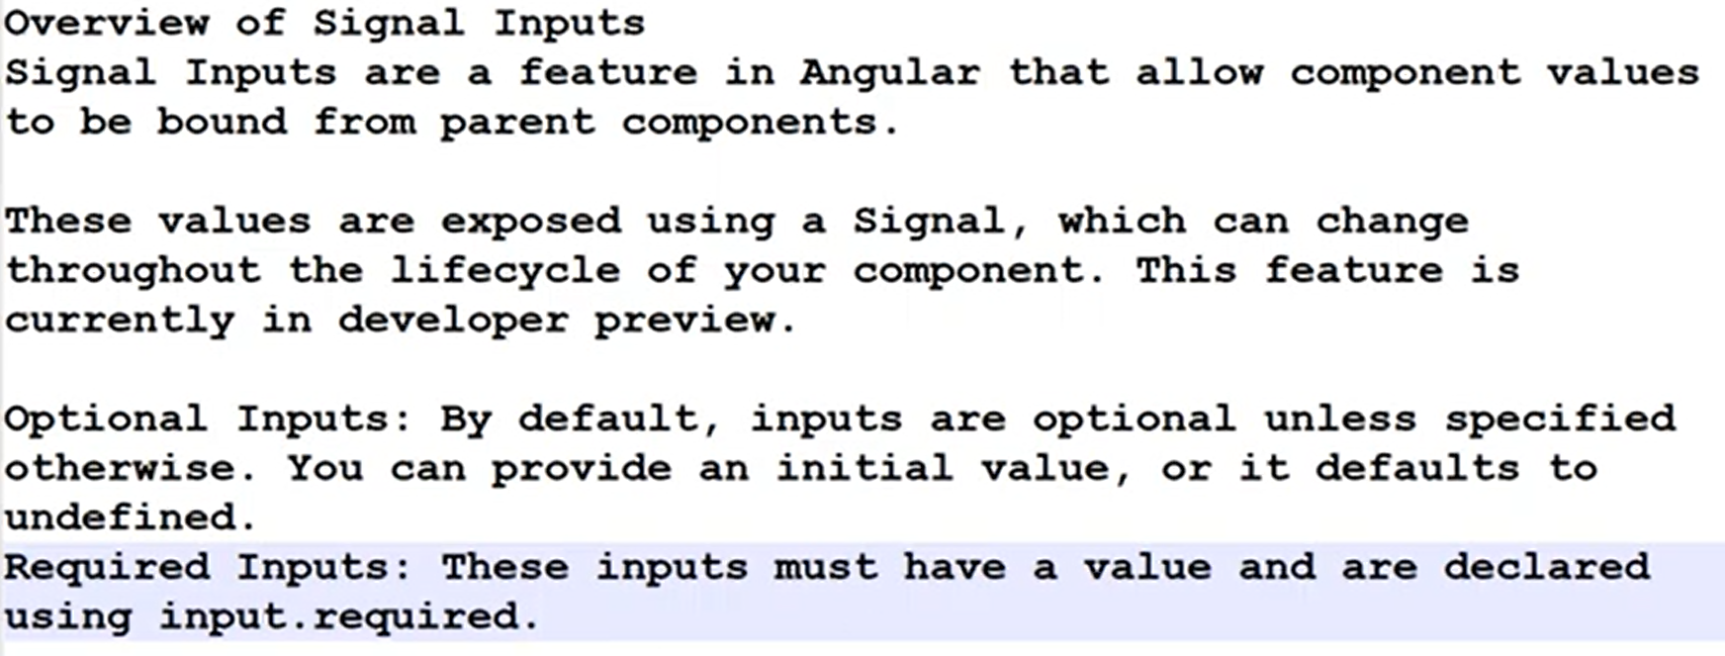  
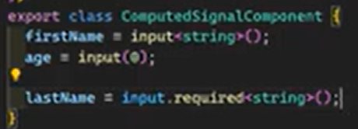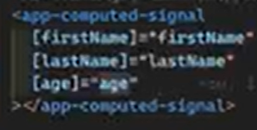  
  
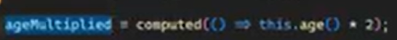  
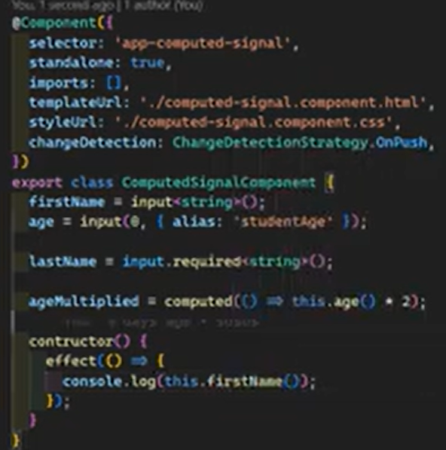  
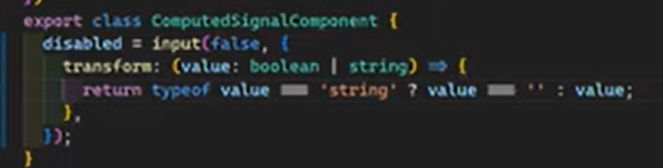**

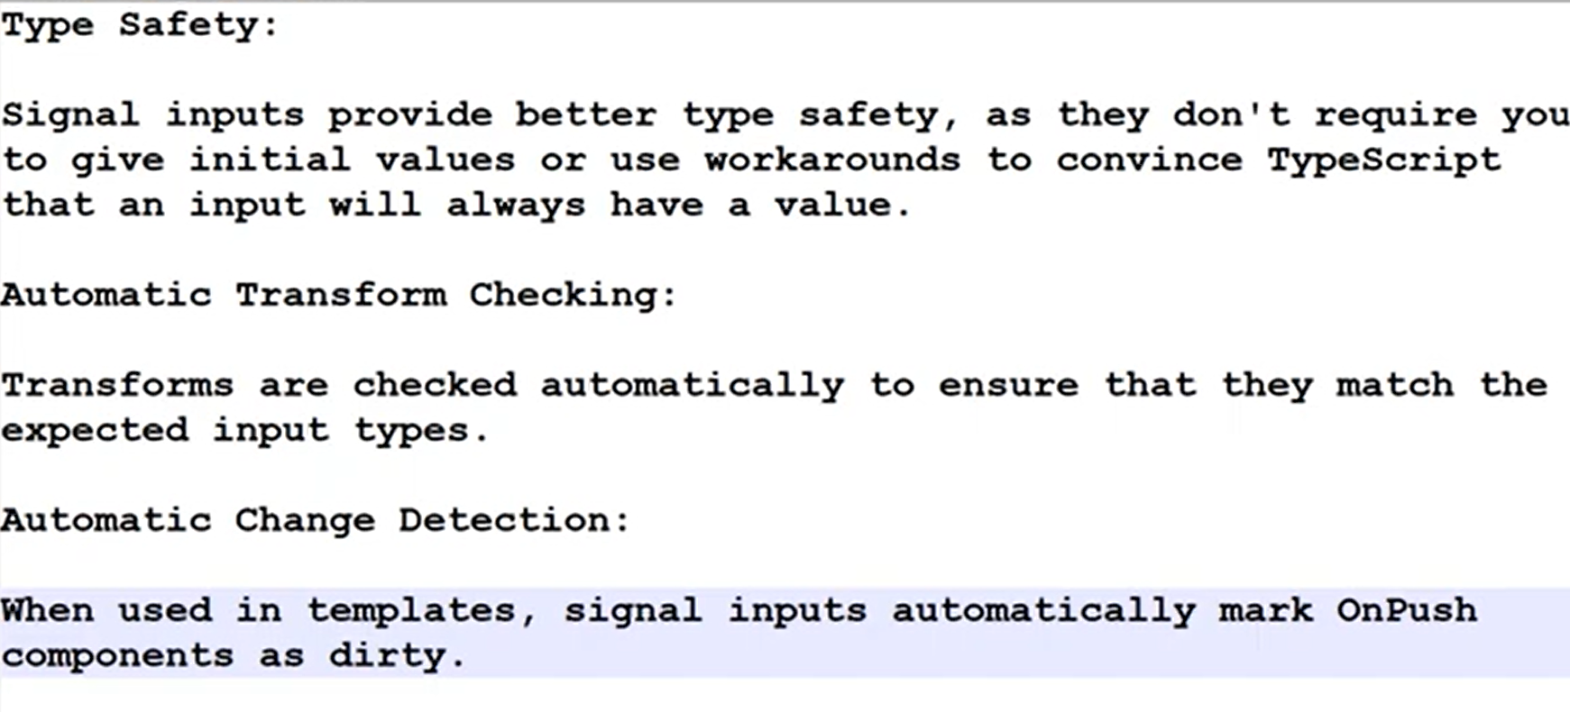

**Model Inputs —--------------------------------------------------------------------------------------------------------**

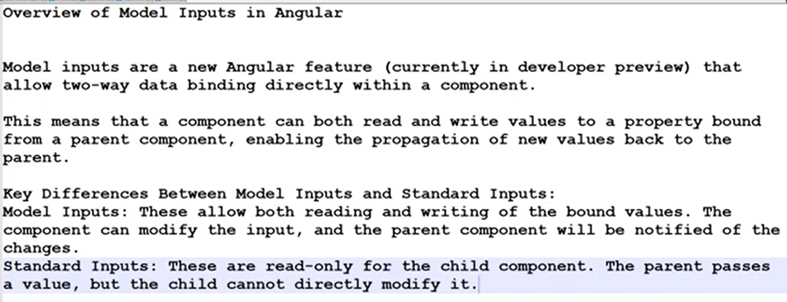

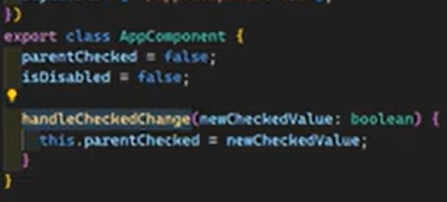

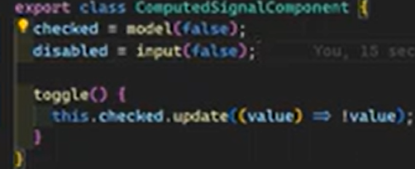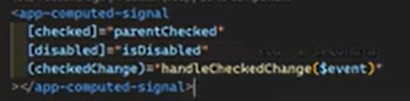

Same behaviour without checkChange method  
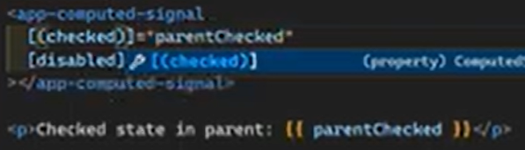

**Signal Queries —------------------------------------------------------------------------------------------------------**

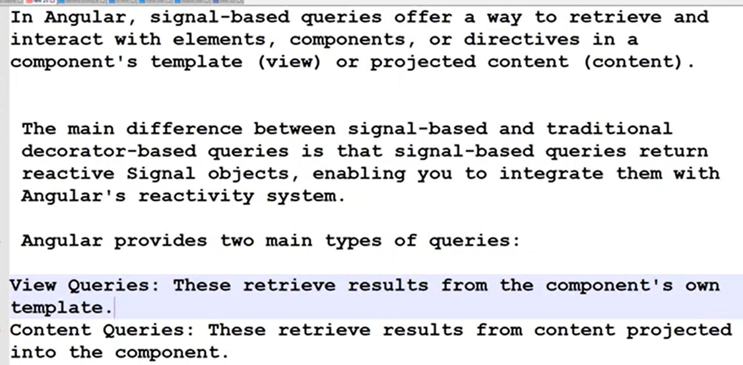  
  
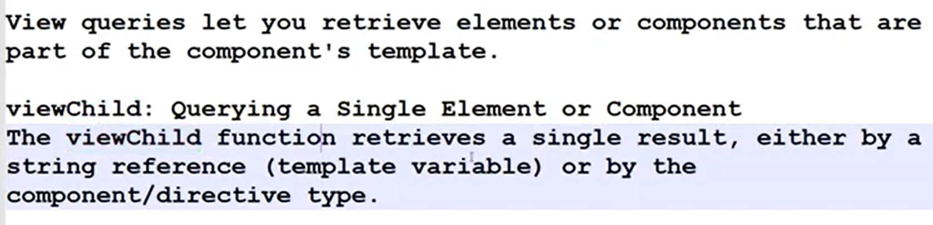  
  
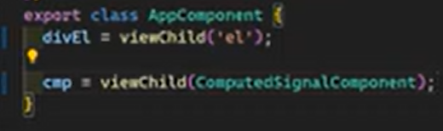  
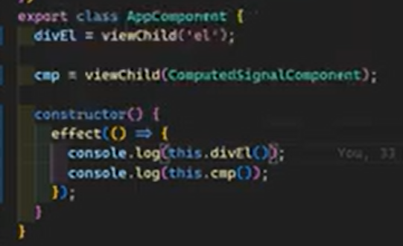

For retrieve multiple elements  
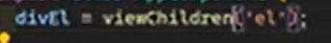  
  
Reading as element  
  
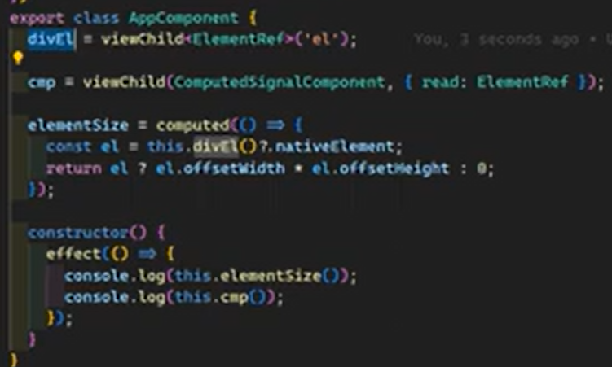 computd signals  
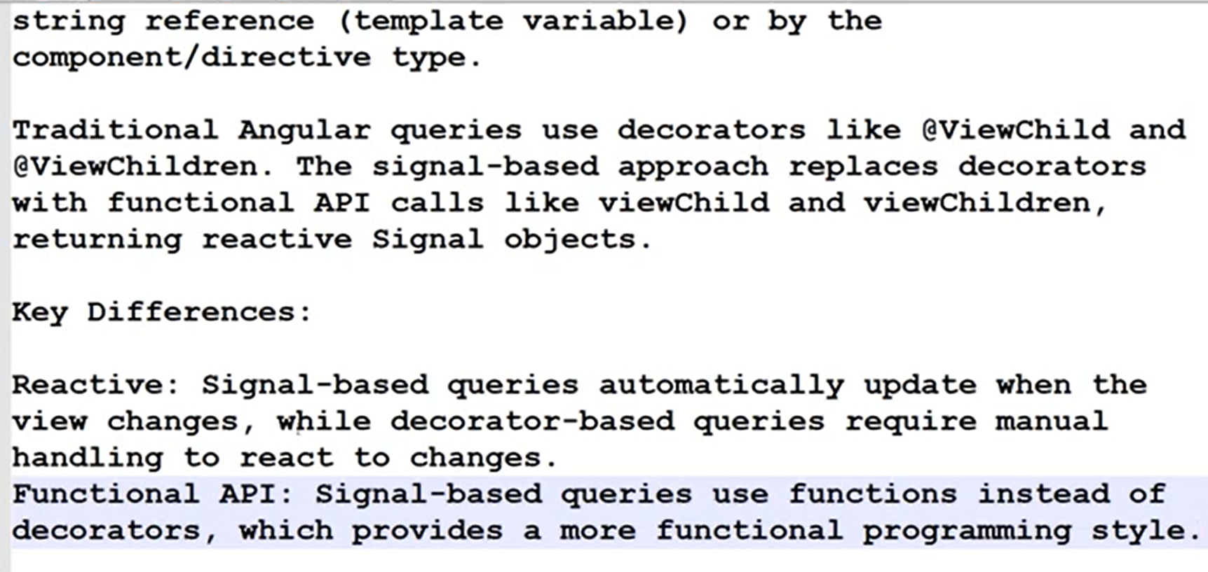

**Content Quries —-----------------------------------------------------------------------------------------------------**

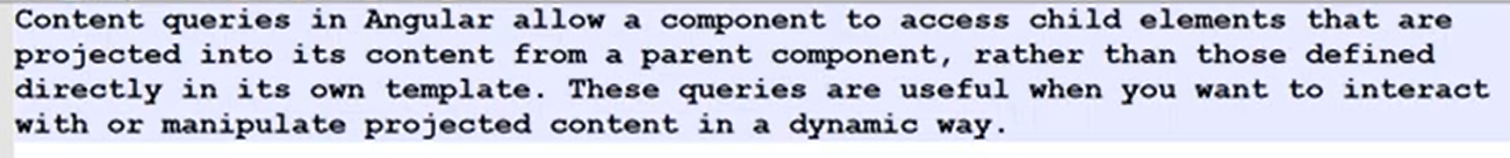  
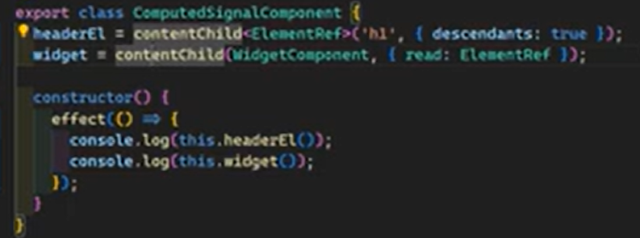  
  
  
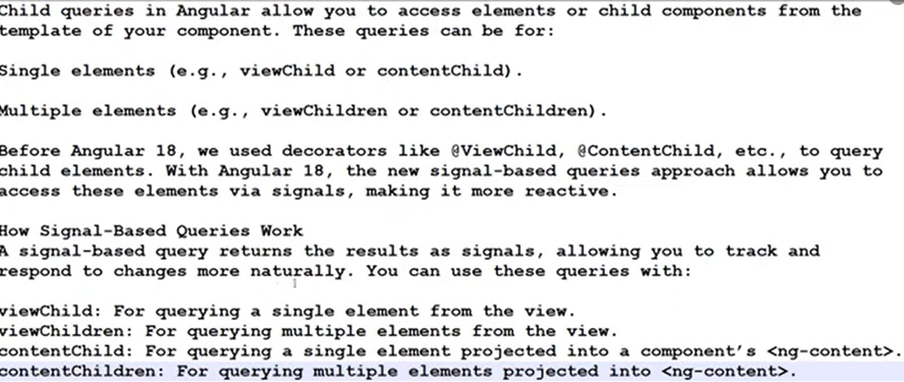  
  
  
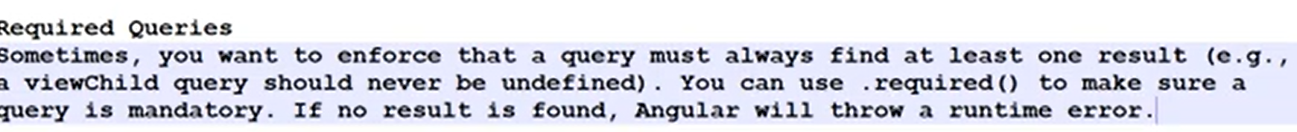  
  
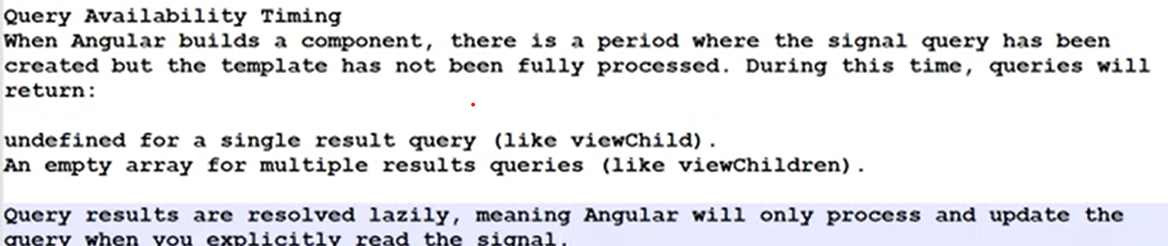  
  
  
  
  
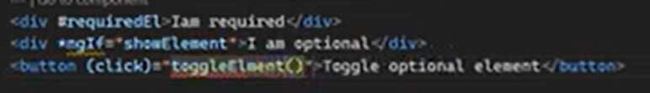  
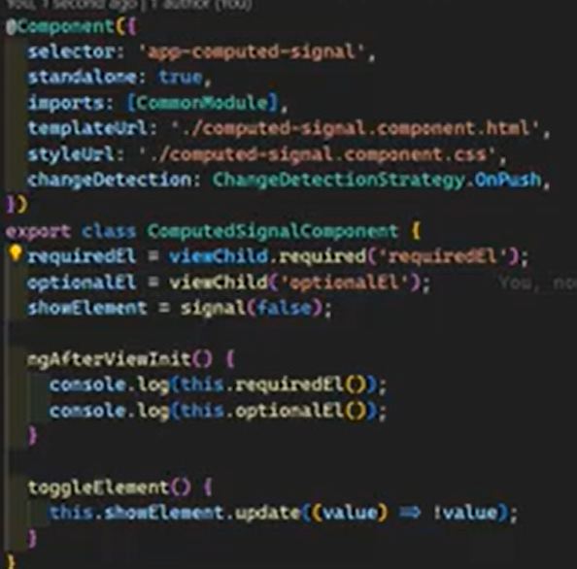  
  
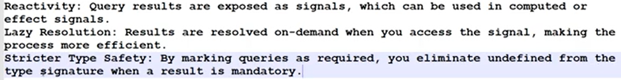

**Routing**

**Route Params & Component Binding  
  
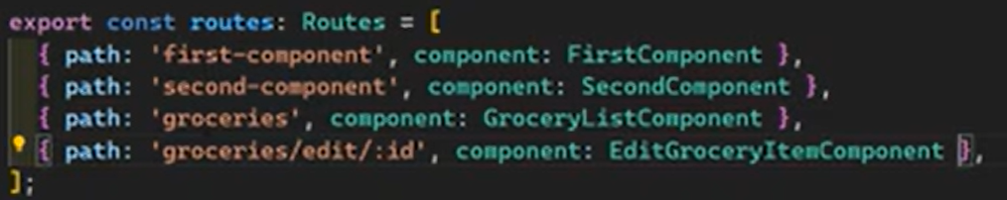  
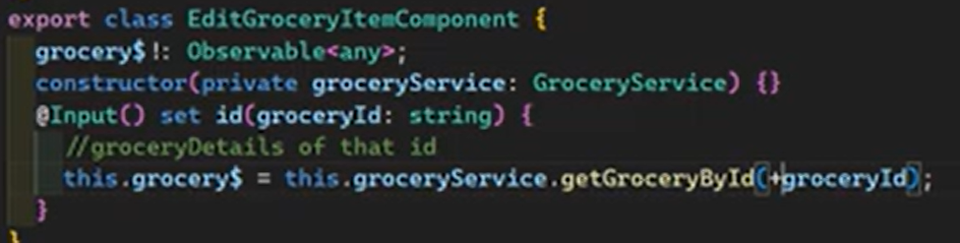**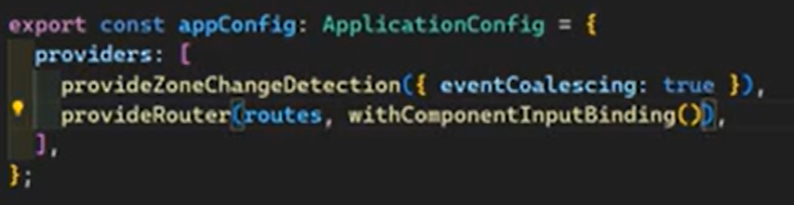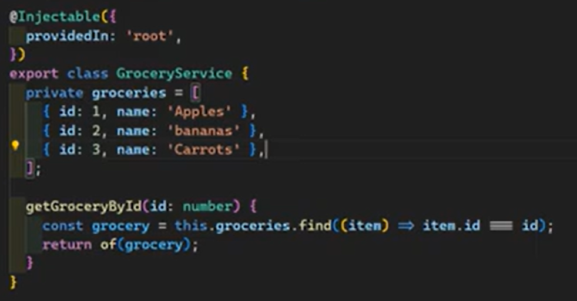

**Parent Route Data Inheritance —--------------------------------------------------------------------------------**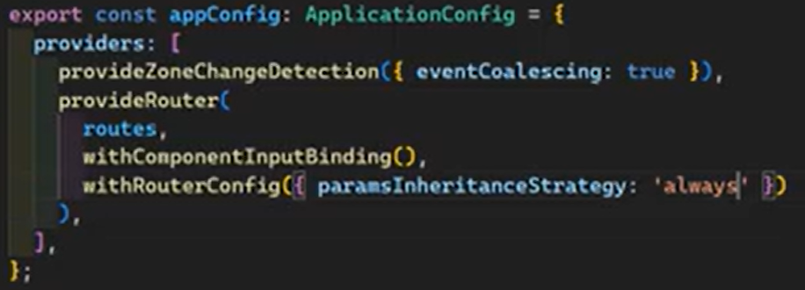

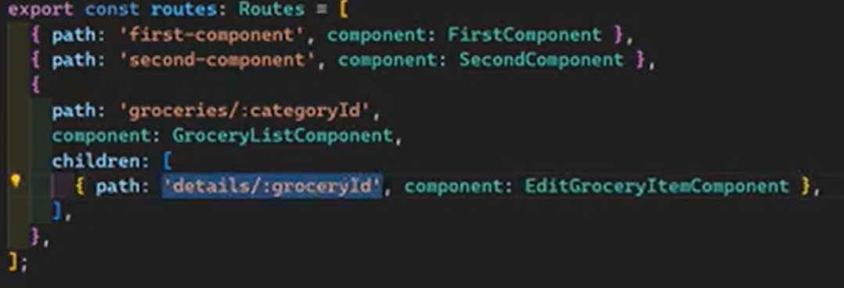  
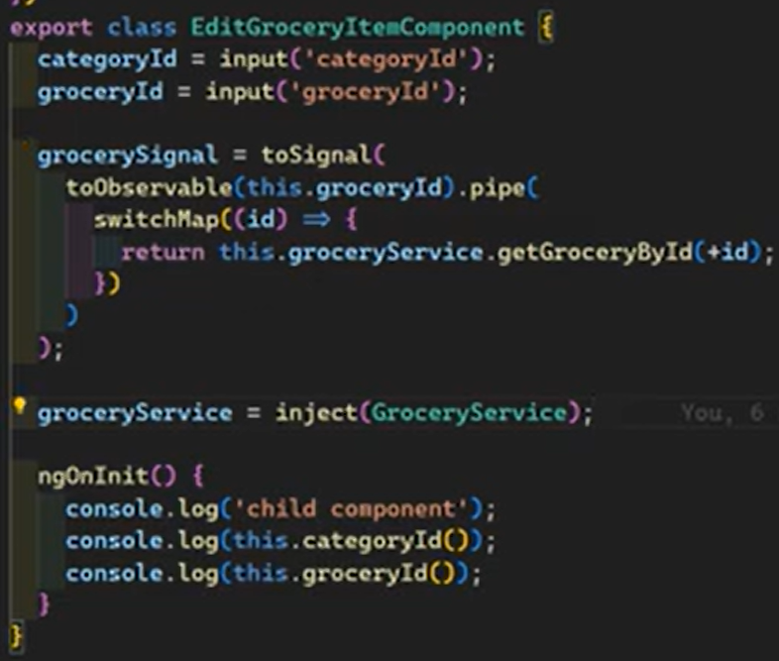

**Wildcard routing and path redirects —------------------------------------------------------------------------**

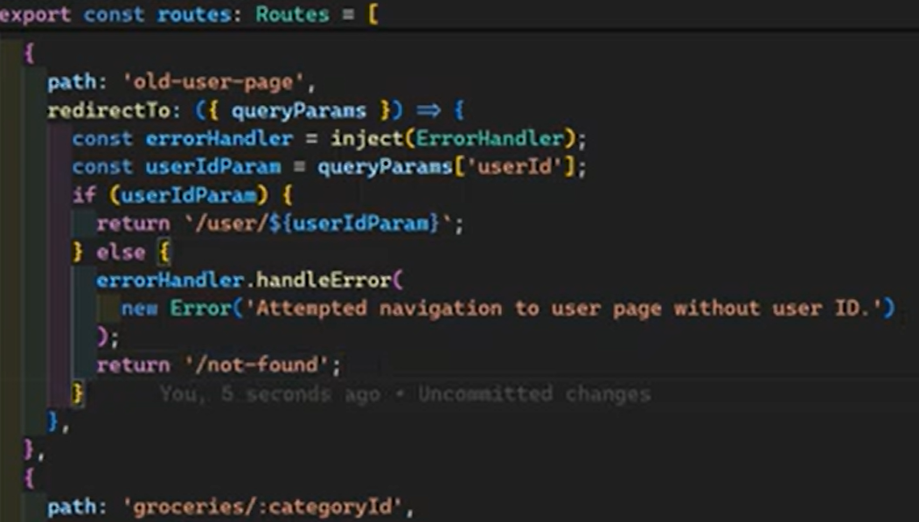  
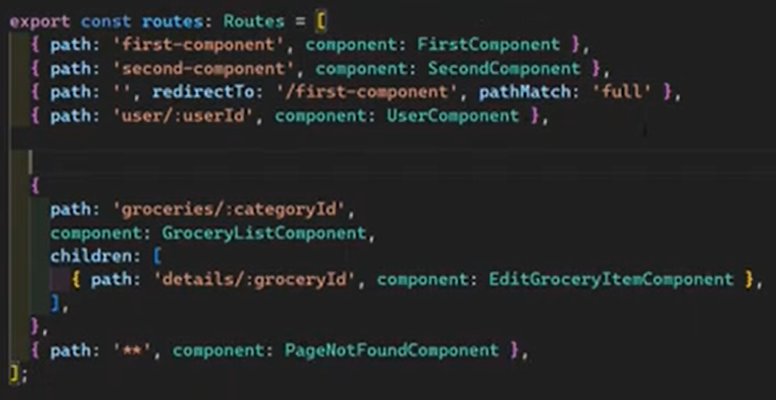  
  
  
 **Nest Routes with Standalone Components —--------------------------------------------------------------**

**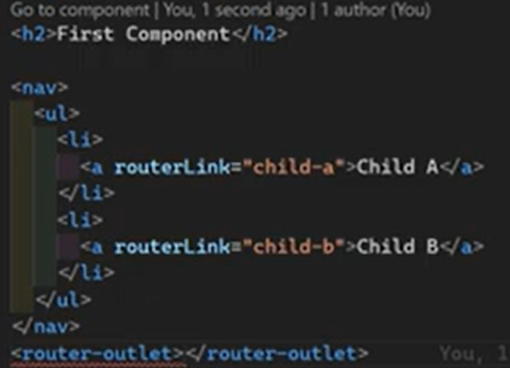  
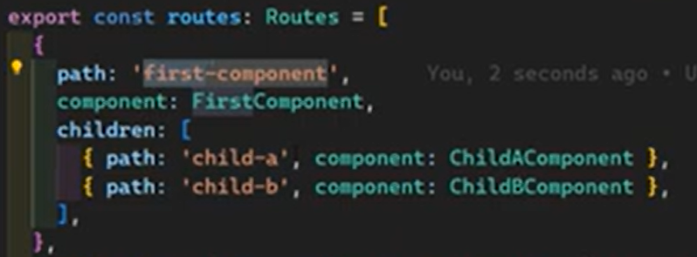**

**Dynamic Page Titles with Template Strategies —----------------------------------------------------------**

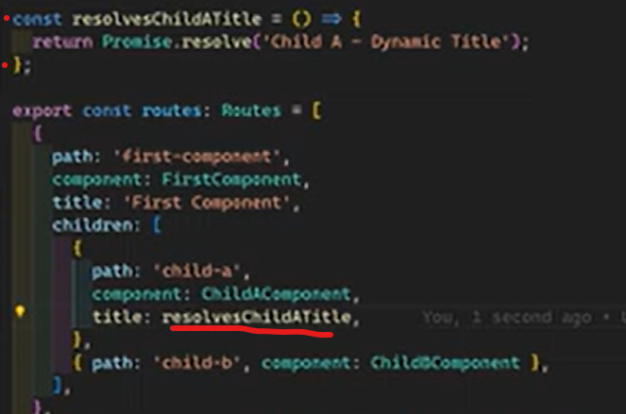We can defined and use custom strategy for titles of the pages  
  
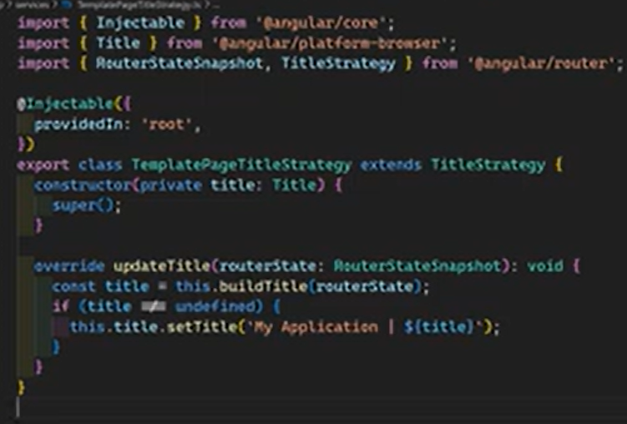  
  
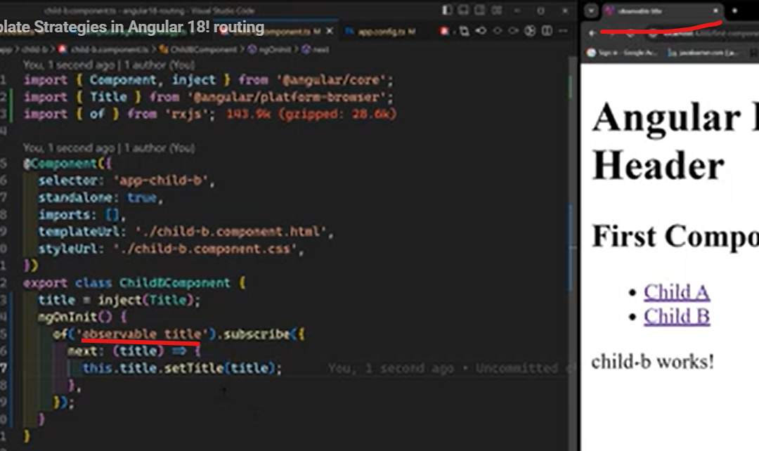  
  
  
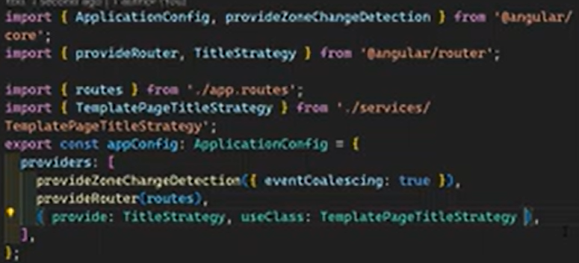

**Relative Routes and Navigating —------------------------------------------------------------------------------**

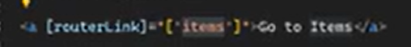  
Routerlink always try to navigate as relative router. If the current location is ‘home’, this will navigate into “home/items”  
  
Absolute routing  
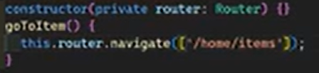  
  
Relative routing  
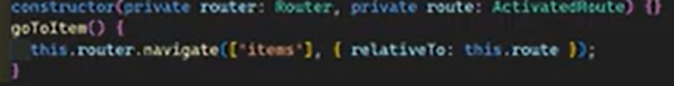  
  
  
  
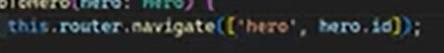

**Sending and Capturing the Dynamic Route Params Programmatically -—-----------------------**

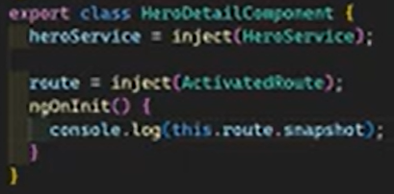 all informations  
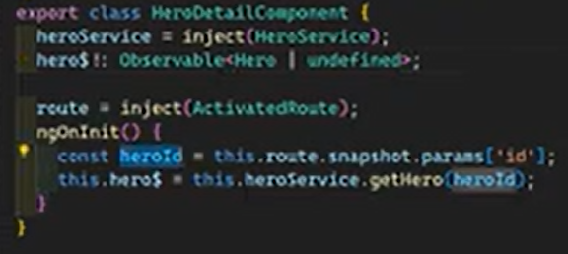 but this will work once since ngOnInit only executes at the beginning, so we need to observe the changes of params  
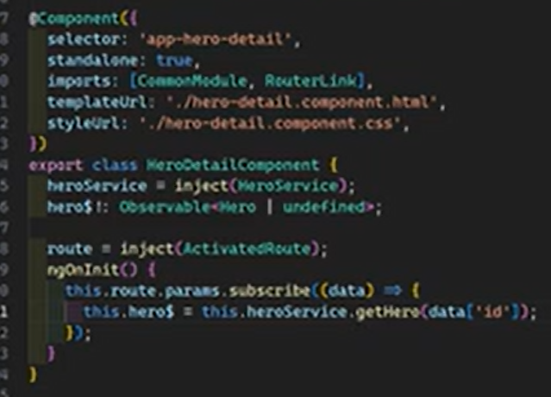  
  
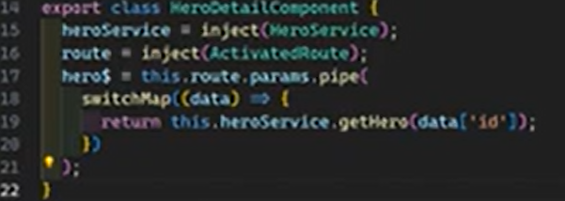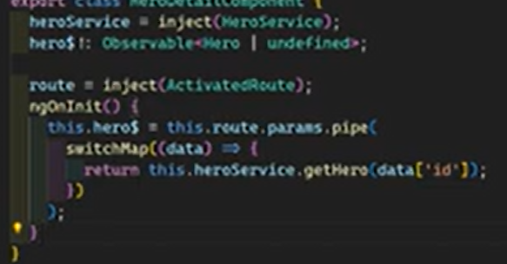

**Query Parameters & Fragments —------------------------------------------------------------------------------**

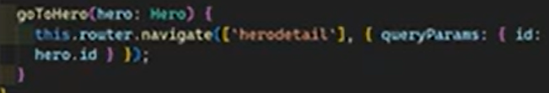

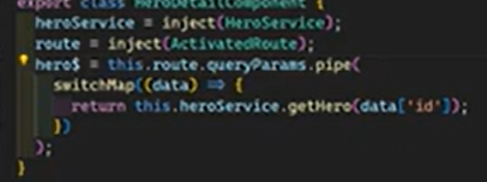  
  
  
  
Fragments  
  
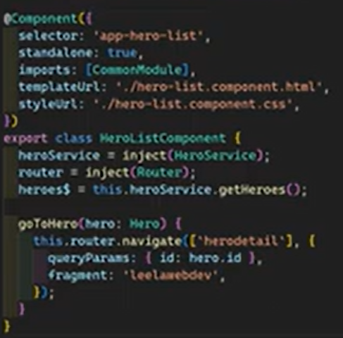  
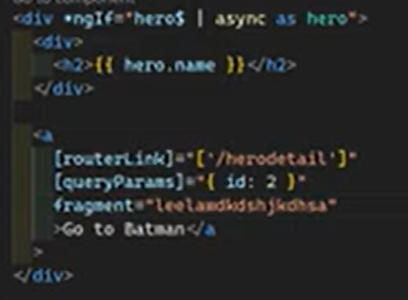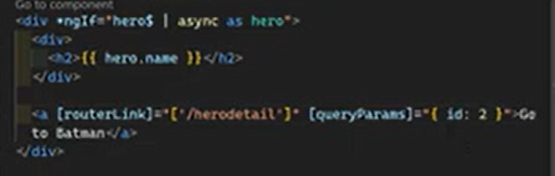

**Lazy loading of standalone components —------------------------------------------------------------------**

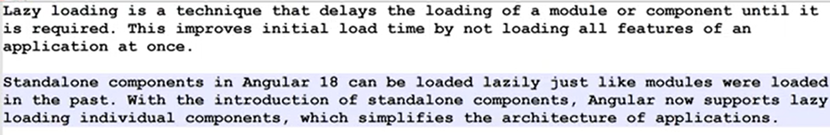  
  
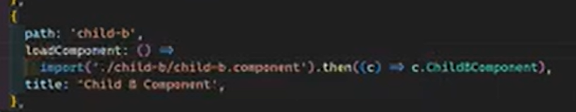

**Route Guards**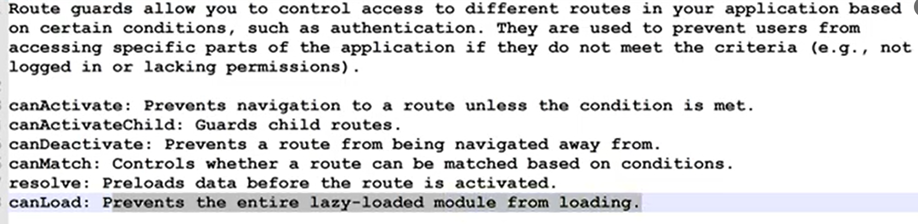

**CanActivate —---------------------------------------------------------------------------------------------------------  
  
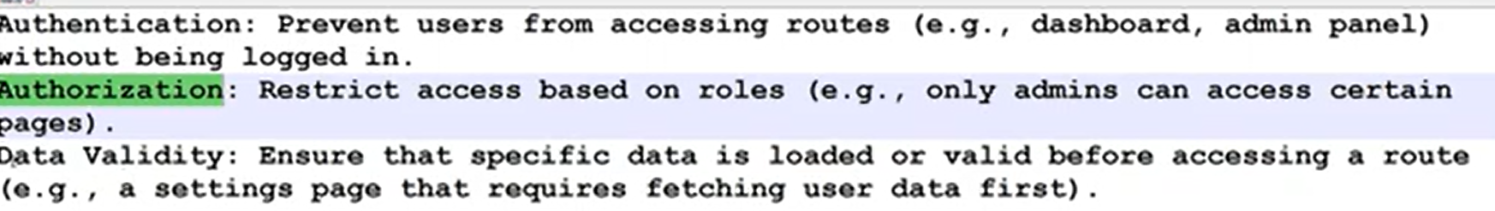  
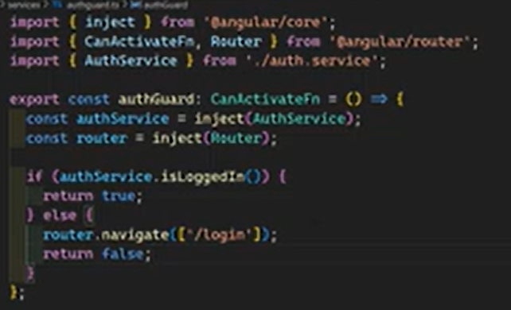  
  
CanActivateChild —--------------------------------------------------------------------------------------------------**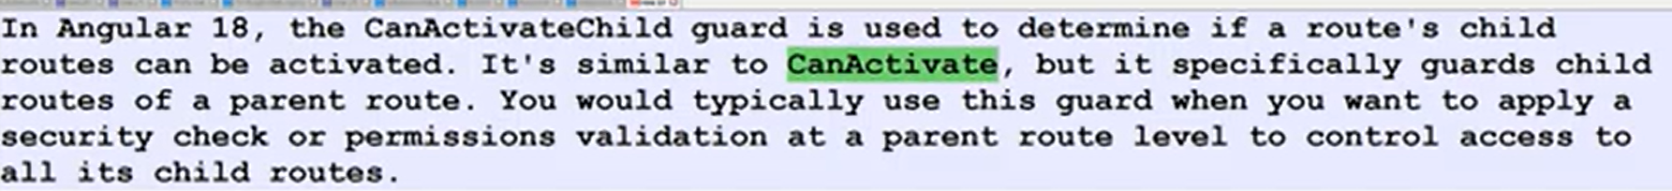  
  
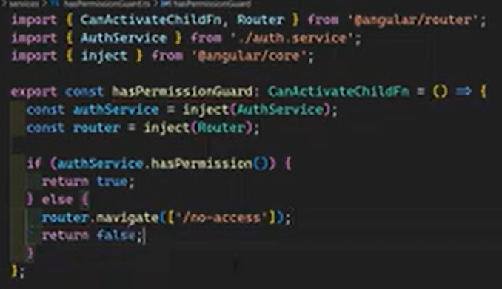  
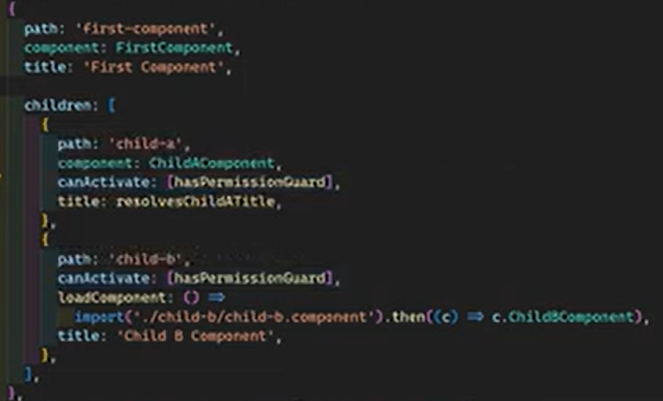 all for child routes  
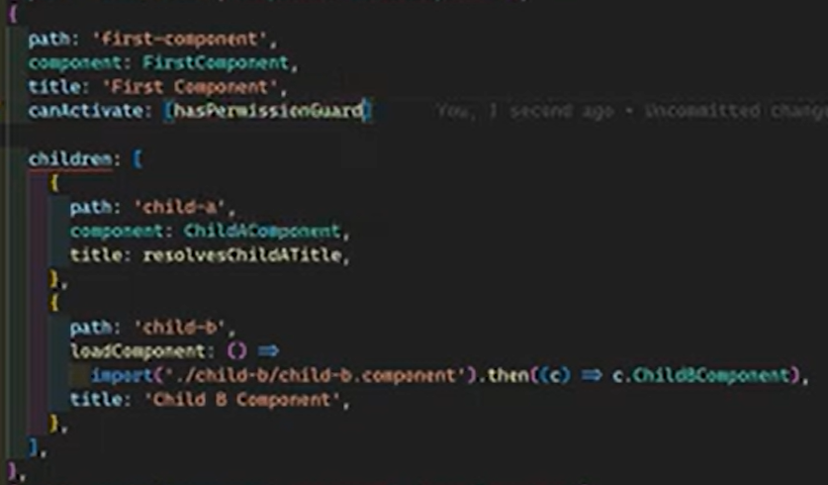 specify once for all child routes  
  
  
  
**CanDeactivate Guard Save Users from Unsaved Data Loss —---------------------------------------**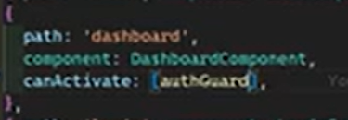

**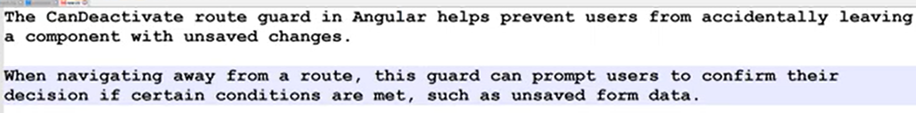  
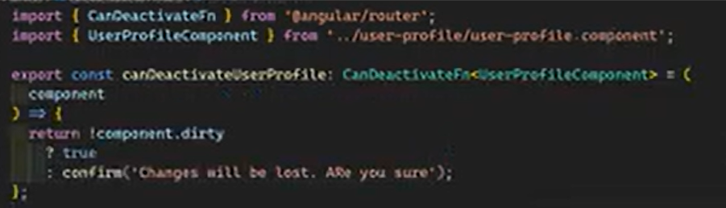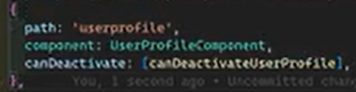**

Reusable generic solution for all components  
 **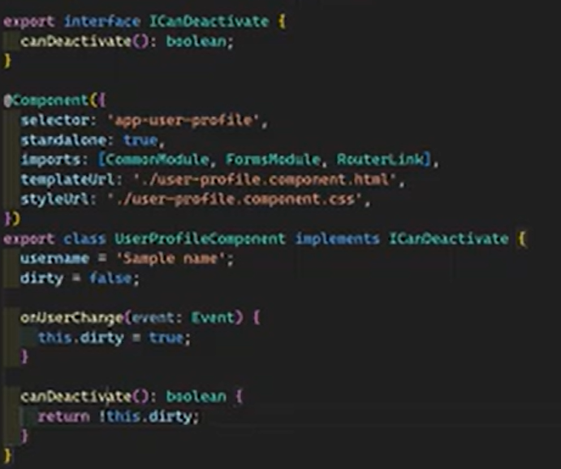  
  
  
CanMatch —------------------------------------------------------------------------------------------------------------  
  
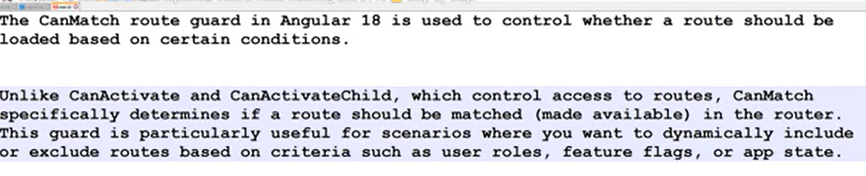  
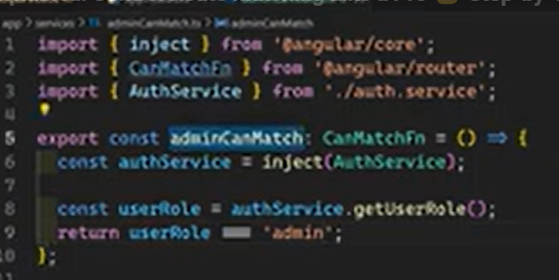  
  
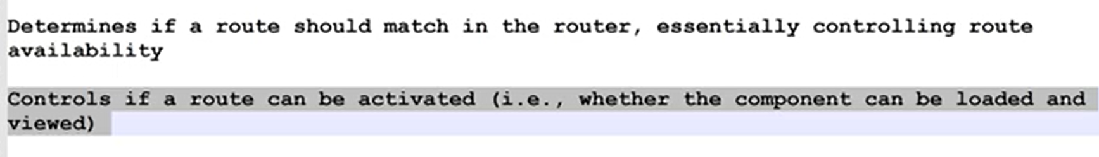  
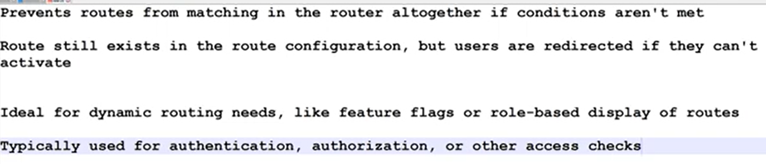  
  
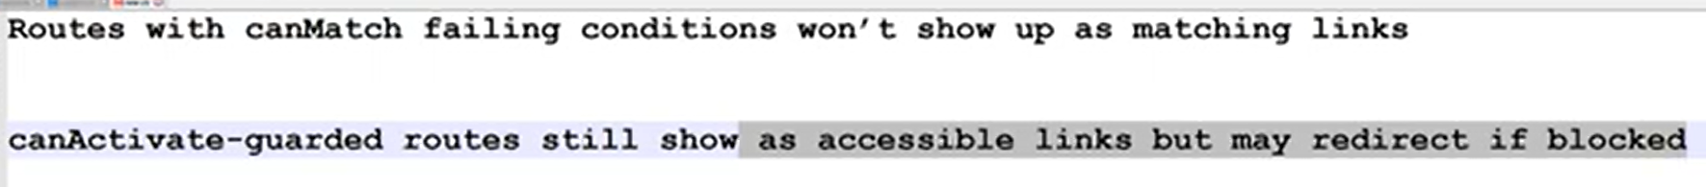  
  
  
  
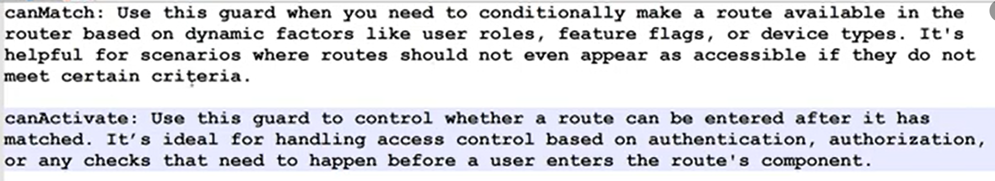  
  
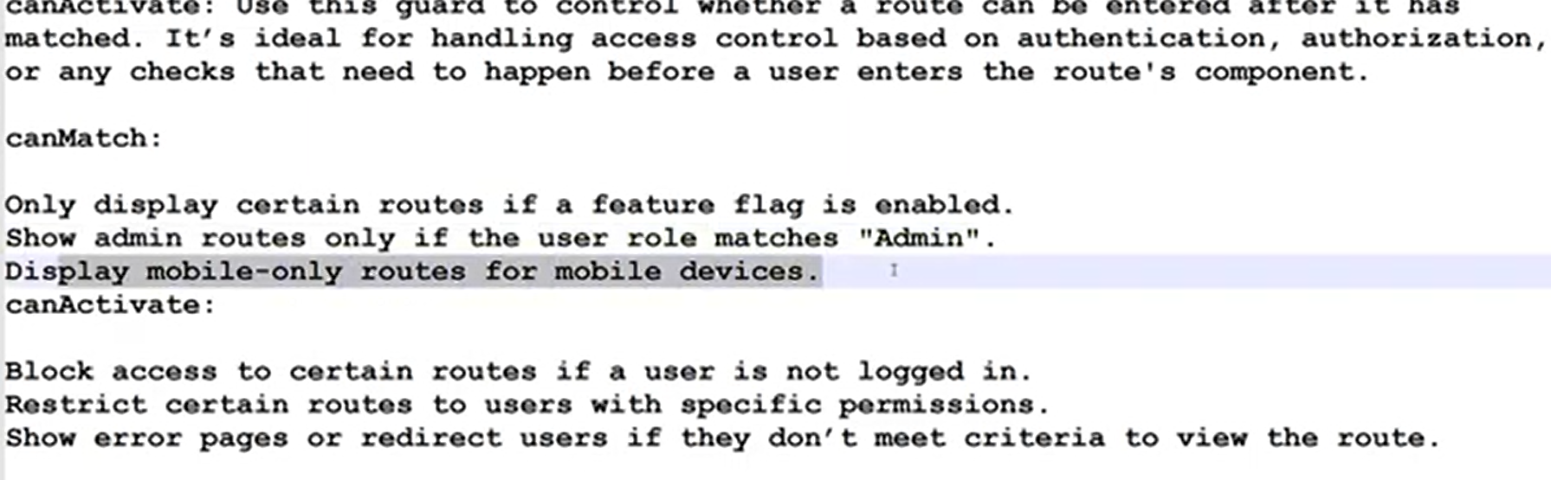**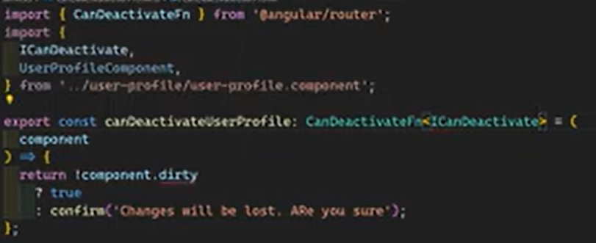

**Resolve —---------------------------------------------------------------------------------------------------------------  
  
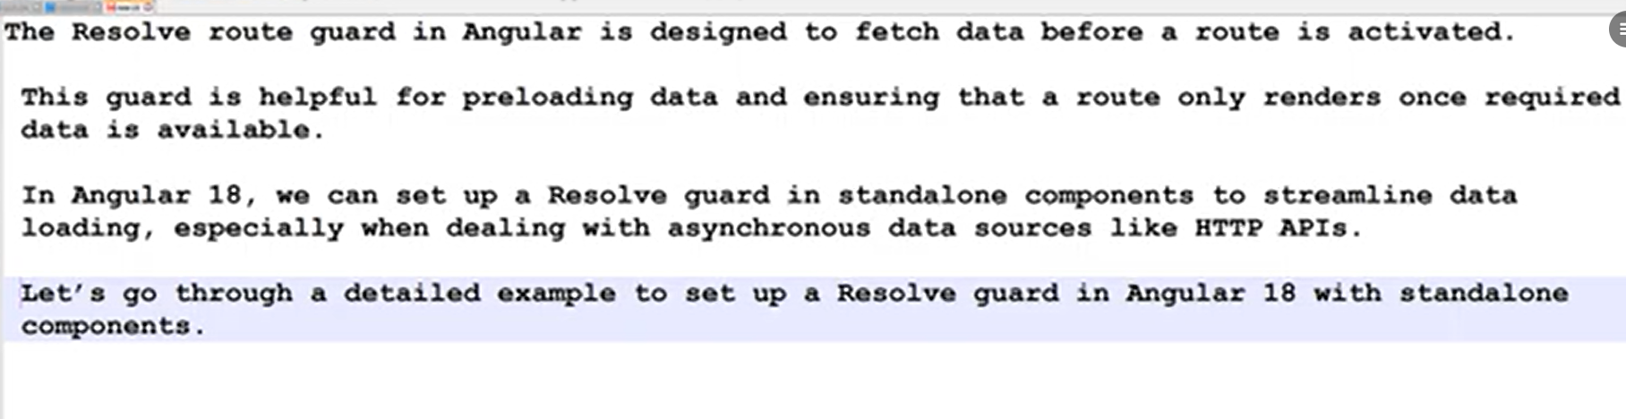  
  
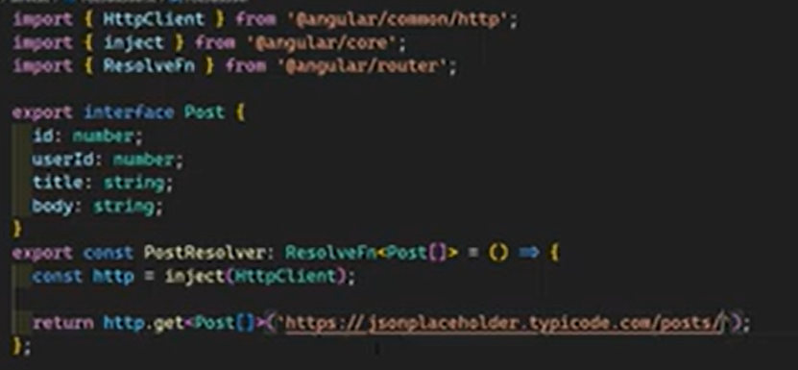  
  
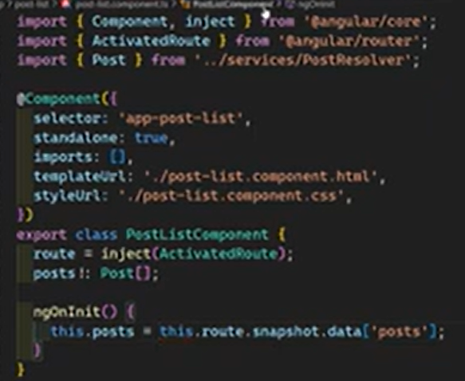 o r  
  
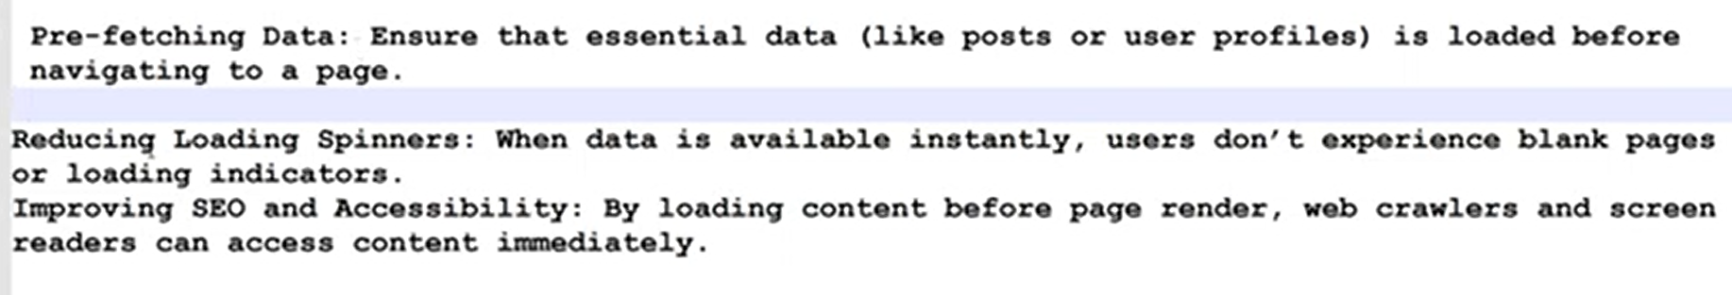**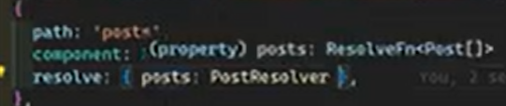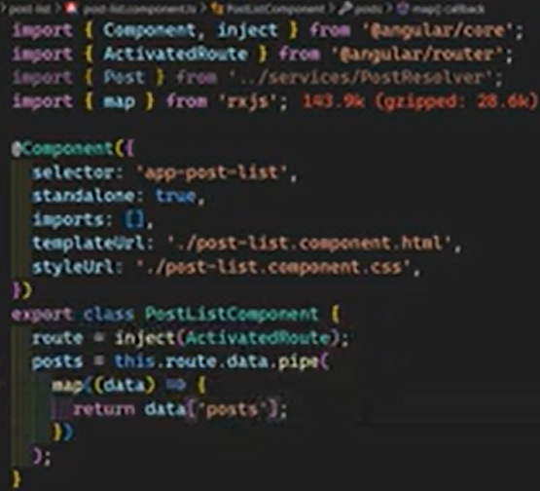

**Path vs Hash —--------------------------------------------------------------------------------------------------------**

**  
  
  
